Lessons Learned 360 Review Module

360 Review Guide – Teachers’ Standards

To begin, go to www.llo.org.uk. Log in using your usual username and password (if you do not know these, please contact us at support@llo.org.uk).
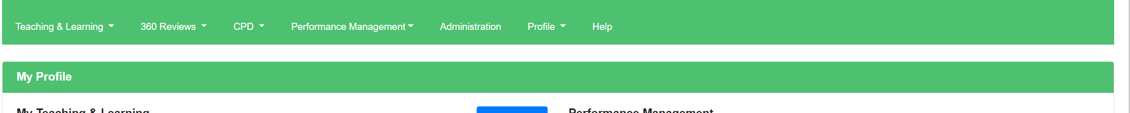
Once you have logged into the system your Lessons Learned profile screen should appear with the navigation bar at the top of the screen (if logged in on a small device such as a phone or tablet, you’ll see three lines ☰ for the menu instead)

Creating a 360 Review
To create a new 360 review, you will need to select ‘360 Review’ on the top toolbar, then ‘Teachers’ Standards’ followed by ‘Create Review’.
You will then need to add a ‘Review Date’ and ‘Review Title’ - making sure the title is relevant, perhaps including the term in which the Review is being conducted.
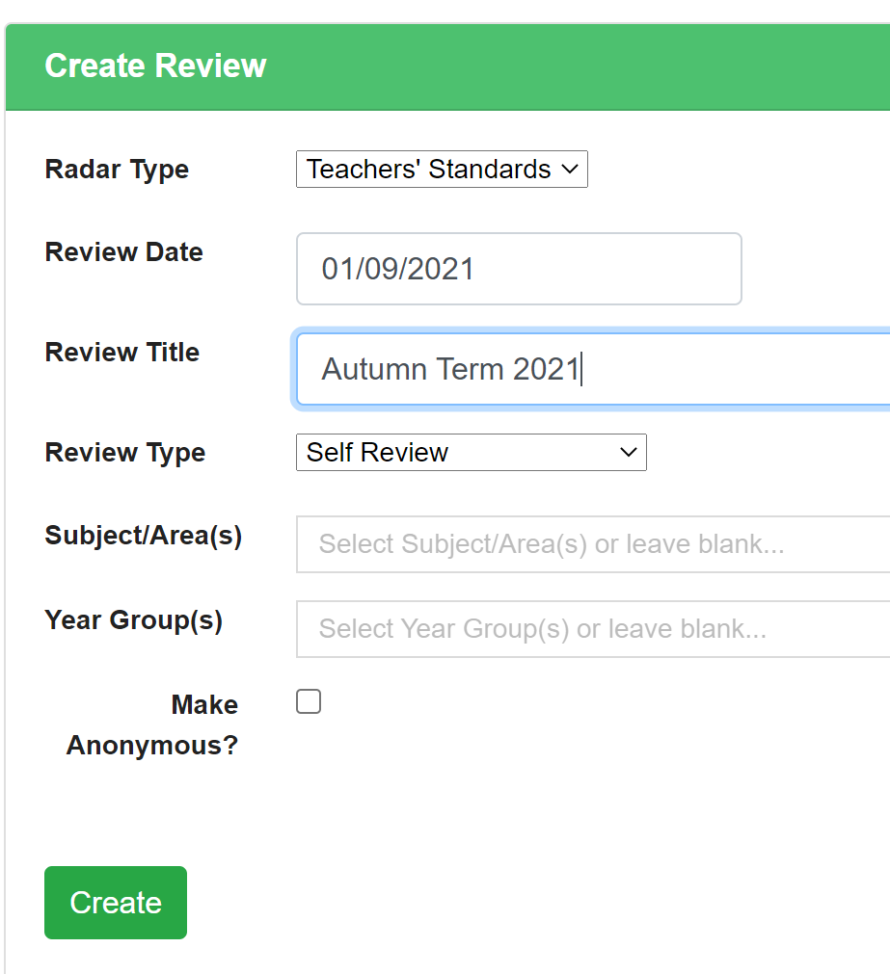
You may be given the option to select what type of review this is from a dropdown list under ‘Review Type’. Depending on your role this may include review types such as ‘Self Review’, ‘Peer Review’, ‘Subject Review’, ‘School Review’, etc.
Once this has been selected you will then get the opportunity to make the review department specific. Simply start typing in the name of the year or subject and it will then appear for selection under the dropdowns - ‘Subject/Area(s)’ and ‘Year Group(s)’ .
N.B – Depending on the review type you are completing; you may see the option to tick and make the review ‘Anonymous’ or to ‘Keep Private’. The anonymous option will replace your name with the word ‘Anonymous’ and the keep private option will hide the review from everyone else in the system, including SLT.
Finally select ‘Create’.

Completing a 360 Review
Once you have selected ‘Create’ it will take you directly into the review document and a spider diagram will appear as below. Each spoke will relate to a Teaching Standard.
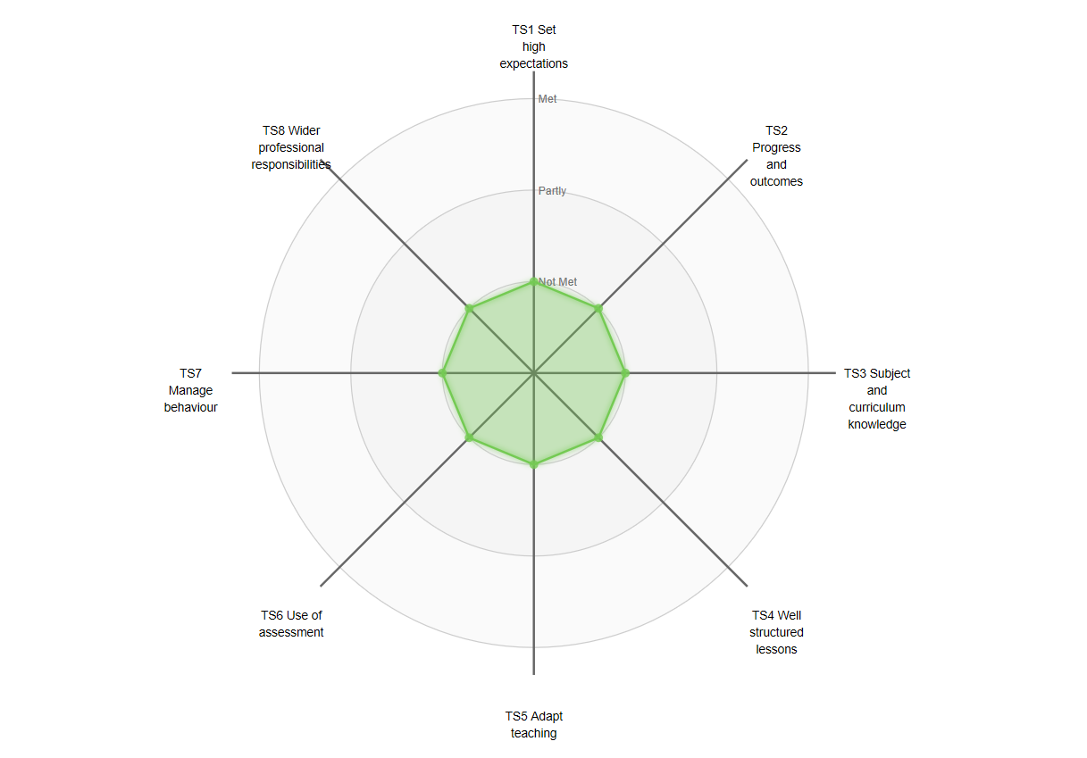

To complete a spoke click on the spoke name to open the pop up. Once this spoke has opened all the sub spokes and sub-standards to complete will be listed. Against each sub-standard there will be a slider which can be moved along a scale of not met, partly met, and met (or something similar, depending on your school set up). Under each slider there will also be a comments box for you to evidence your assessment.
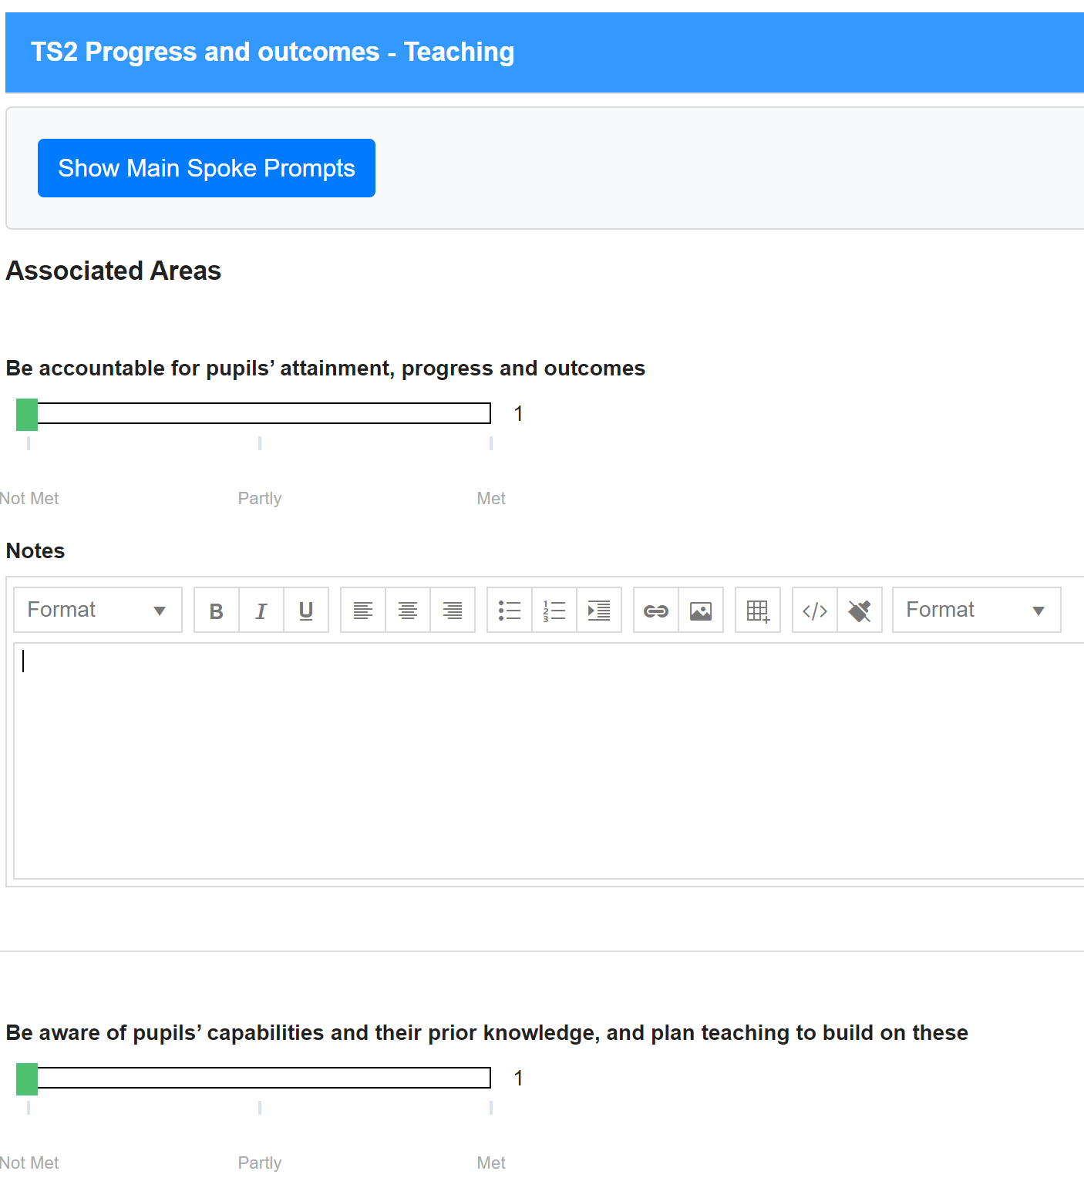

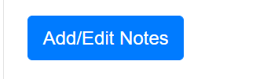
Alongside each spoke you will see you will also see the option to ‘Add/Edit Notes’. Using this feature will allow you to add a professional development note as seen within the image below.
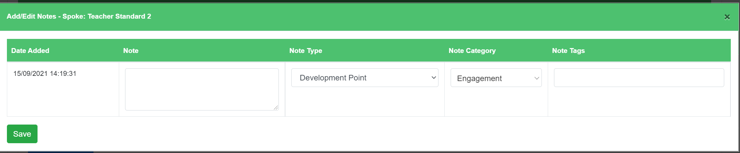
Once you have followed the process of completing each sub-standard, there will be an overall judgement that will calculate automatically, which will be an average of what has been selected above. If you feel this overall judgement does not show a true reflection of your practice in this area, you have the option to override the automatic calculation, but bear in mind it will be flagged that you have chosen to do so. At the bottom of every spoke there will also be an option to add any attachments and links as evidence.
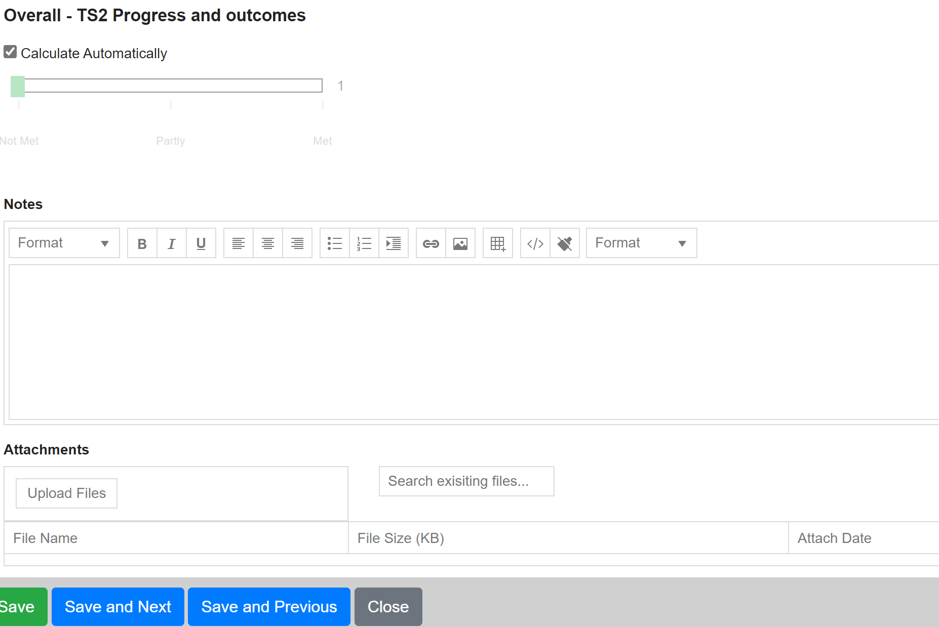

To move on from this spoke you can use the four options at the bottom of the page to navigate your way. For example, if you select the ‘Save and Next’ button, this takes you to the next spoke along on the radar chart. Always remember to ‘Save’ any evidence before selecting the ‘Close’ button.

Viewing 360 Reviews
Click ‘360 Review’ followed by ‘Teachers’ Standards’. Select ‘View Reviews’ and the screen will refresh to show you all the of the reviews you have been given access too. If you are head of a department, you will have access to the reviews that have been created accordingly.
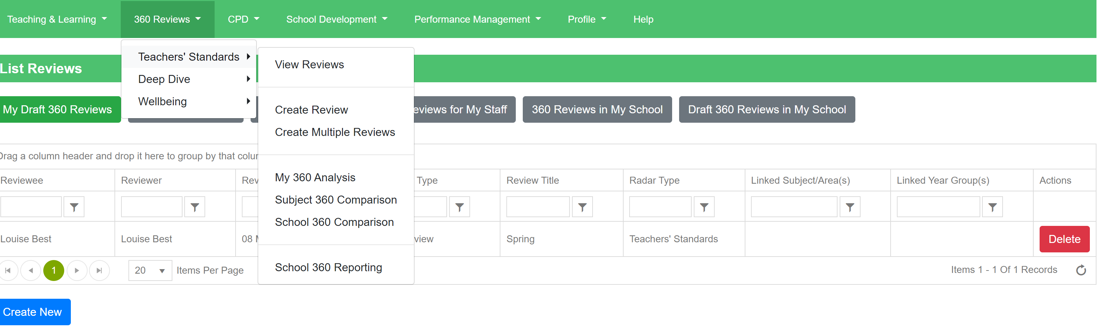
To view any of the listed reviews click on the review and the screen will refresh and show the information required.
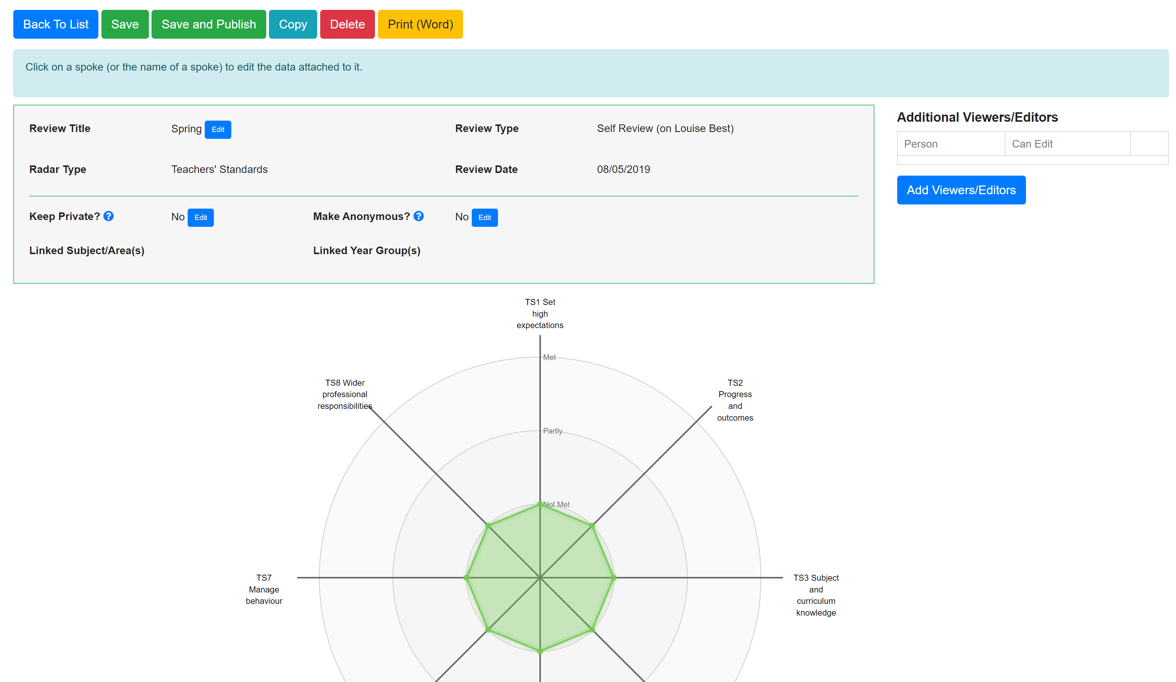

Editing a 360 Review
Click ‘360 Review’ followed by ‘Teachers’ Standards’. Select ‘View Reviews’ and the screen will refresh to show you all the of the reviews you have been given access to.
To edit a review you have already started, you will need to go to ‘360 Review’ followed by ‘Teachers’ Standards’ and then select ‘View Reviews’. Within the first tab you’ll find a list of the 360 reviews you have created but not yet published. Click the review in the table that you would like to edit.

Publishing a 360 Review
First, you will need to find and open the 360 review you would like to publish. At the top right of the review document, you will see a green button to ‘save and publish’.
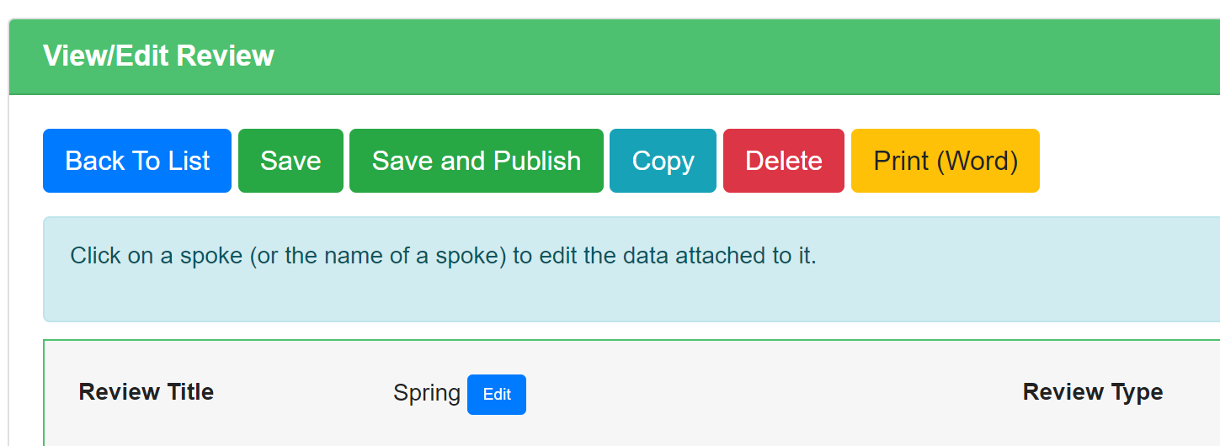
Completed and published reviews can then be compared by layering the reviews one on top of the other, giving you instant, high-impact visual reports of progress at all levels.

Analysing 360 Reviews.
Click ‘360 Review’ followed by ‘Teachers’ Standards’ and then select ‘My 360 Analysis.’
You will then need to select the ‘Edit Data’ button in the right-hand corner of the screen.
Use the ‘Select Reviews’ option to add individual reviews to your comparison or select ‘Add Average’ to build your own averages from multiple reviews. As an example, you may choose to compare your most recent review with your review from the previous term. If anybody has completed any peer reviews for you, you might also wish to compare your review against a peer review (or an average of all peer reviews completed for you).
