Lessons Learned CPD

Help Guide

To begin, go to www.llo.org.uk. Log in using your usual username and password (if you do not know these please talk to your school administrator).
Once you have logged in you will see your Lessons Learned profile page and your navigation bar across the top of the screen (if logged in on a small device such as a phone or tablet, you’ll see three lines ☰ for the menu instead).
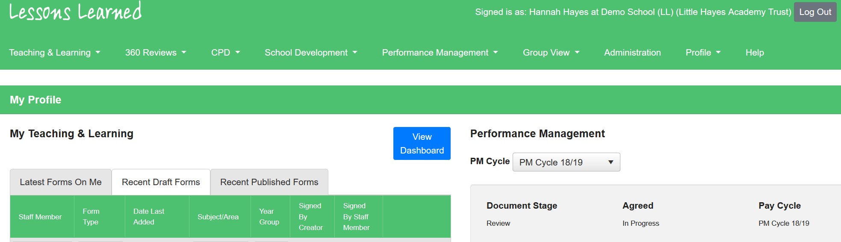

Logging or Requesting a CPD Course or Event
Select ‘CPD’ from the toolbar, followed by ‘My CPD’.
This will then direct you to your personal CPD dashboard, where you will see your CPD log.
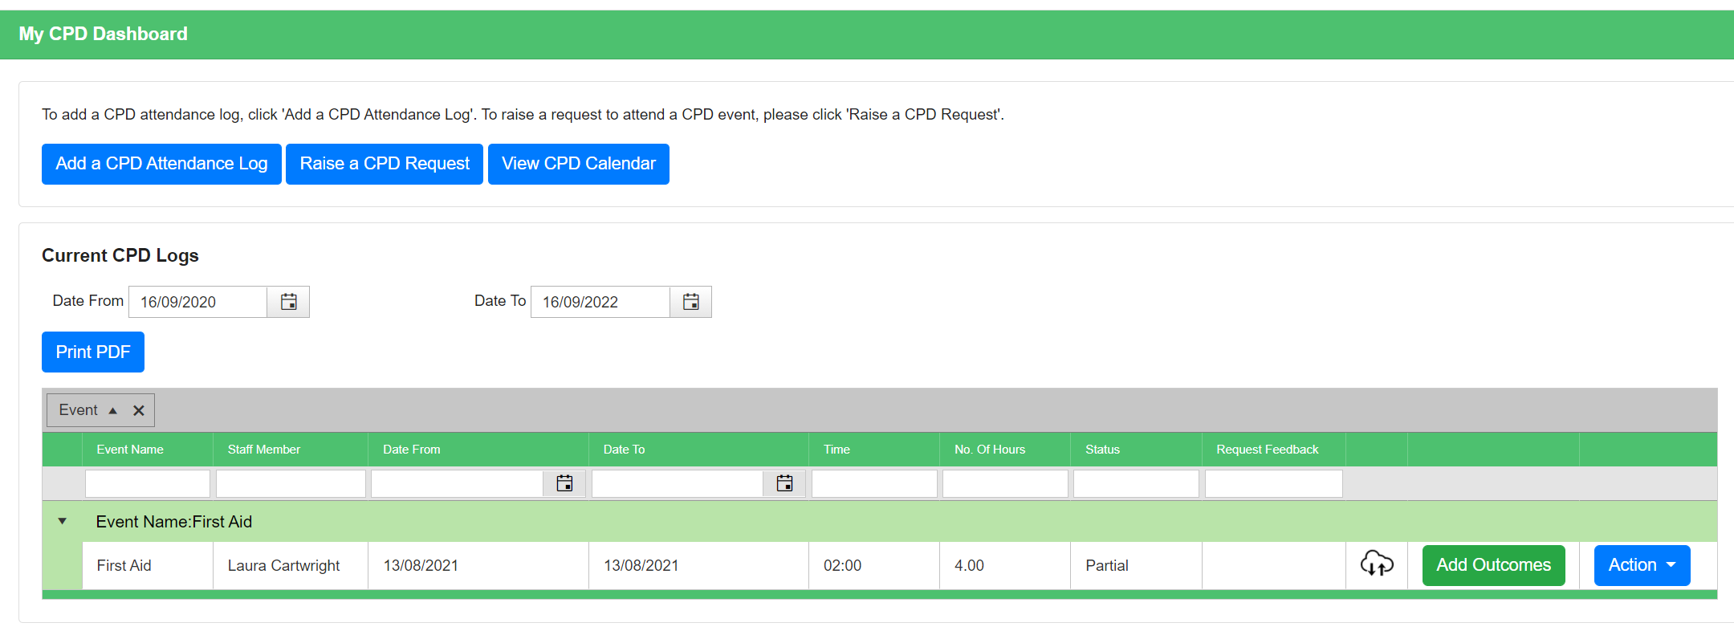
You can add a CPD attendance log for any event that you’ve already attended and/or for anywhere you do not need authorisation to attend. The request button is for any event where approval is required. Both buttons take you on a similar journey through the system, but the request button prevents you from adding your feedback until the CPD has been approved. Once you have selected the appropriate option, the process of entering the CPD details will be the same.
Step 1. Begin typing the name of the event in the box as seen in the image below. If anyone in your organisation has previously attended the event or if your CPD coordinator has already added the event, the pre-populated details will appear for you. If the event is not already on the system, you may be able to add it using the ‘Create New Event’ button, but sometimes schools restrict access to this button to CPD Coordinators (in which case you will not be able to click the button). If you need to create a new event and are not able to, please contact your CPD coordinator or our support team.
Step 2. If you are creating a new event, you’ll be able to use the drop down lists to capture the details of the event. If you’ve selected an event already on the system, you’ll see these details but won’t be able to edit them.
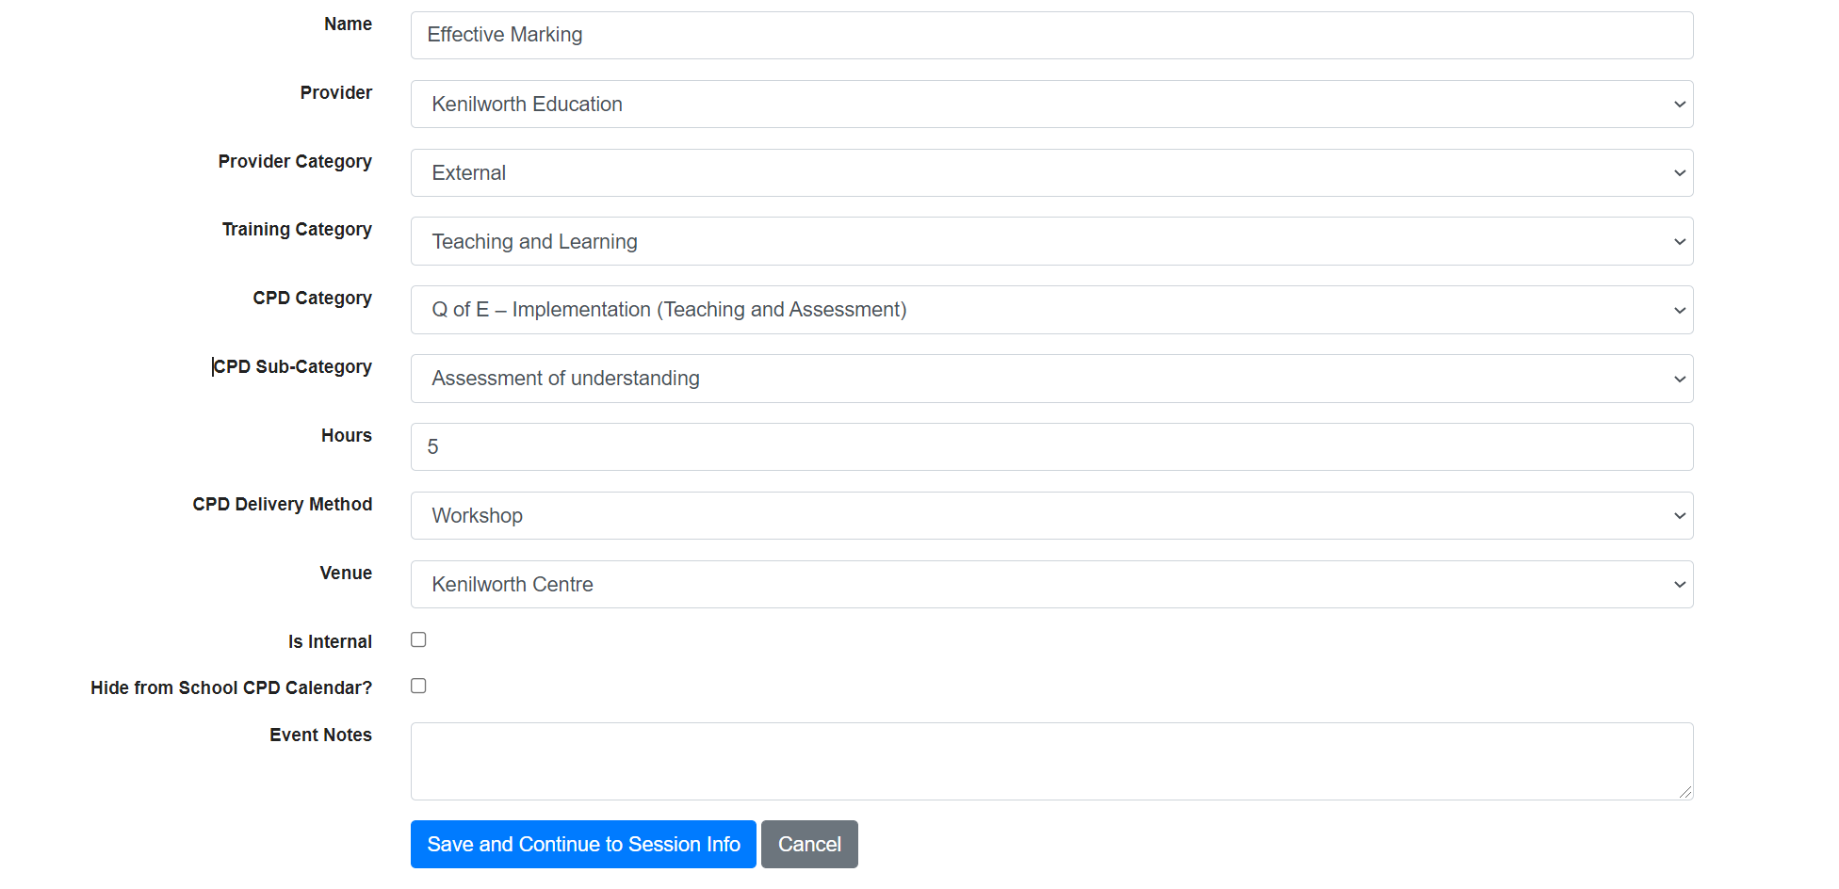
Next, click ‘Save and Continue to Session Info’.
Step 3. The next screen will prompt you to enter the date(s) and time of the event. If the cost is known, or the event takes place over a number of weeks/sessions, please fill in the relevant details. If somebody else has already recorded the same session you plan to attend, you can instead select this from the ‘Choose Exisiting Session’ dropdown.
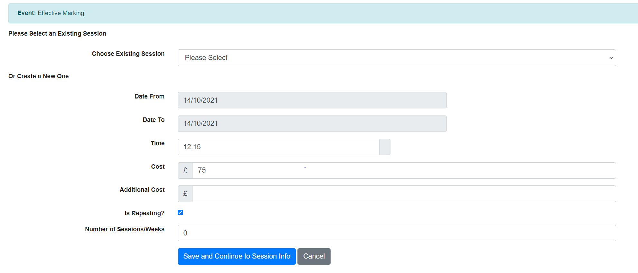
Click ‘Save and Continue to Session Info’.
Step 4. The next step requires you to give reasons for attending the CPD event. Depending on the additional modules your organisation subscribes to, you may be able to link to priorities from your school development plan, professional development notes, and any outstanding performance management objectives.
You will also be asked for ‘Individual reasons for CPD’. You may want to take into consideration the following:
- How does it relate to priorities from your School Development Plan?
- How does it relate to any individual development points or objectives you may have?
- How do you plan to use what you learn when attending CPD (‘My Plan to Disseminate Knowledge’)?
You may also indicate here whether cover is required or if the CPD Event is renewable.
Step 5a. If you’ve gone through the ‘request CPD’ route, you will now see a button that says ‘Submit Request’, which will then redirect you back to ‘My CPD Dashboard’ where you will see your recently added request. If you need to make any amendments to the CPD Request you can do so using the ‘Edit’ button. Under the ‘Actions’ button, you are also able to ‘Delete’ the event if no longer required.
Step 5b. If you have added a CPD log, you can continue to the final stage and add your outcomes/feedback by clicking ‘Save and Continue to Outcomes’.
Use the form on the next and final page to record the impact of the CPD you attended. Did you achieve your expected outcomes? How would you rate the CPD in terms of its effectiveness?

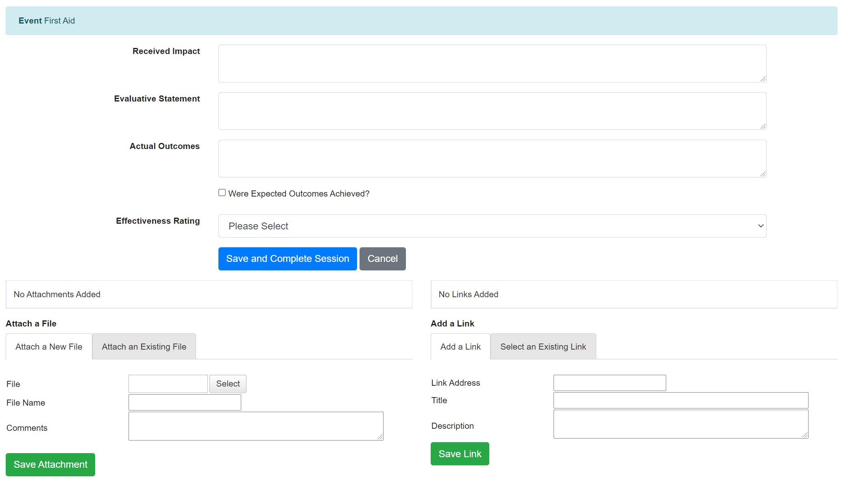

You will also have the option to upload any attachments and links to the CPD event log. This can include things such as certificates or records of achievements.

