Lessons Learned - Performance Management Module

Appraisee/Coachee Guide

To begin, go to www.llo.org.uk. Log in using your usual username and password (if you do not know these please contact us at support@llo.org.uk).
Once you have logged in you will see your Lessons Learned profile screen and your navigation bar across the top (if logged in on a small device such as a phone or tablet, you’ll see three lines ☰ for the menu instead).
Accessing Your Document
Click ‘Performance Management’ followed by ‘Documents’ and the screen will refresh to show you all the appraisal documents with which you are involved.
To open a particular document, click the ‘Actions’ button followed by ‘Edit’ on the right-hand side of the table.
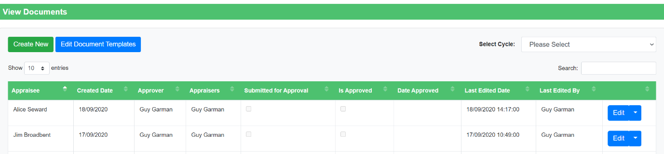
When the page has refreshed you will be presented with your appraisal form. At the top of the page there are several buttons. The ‘View Preamble’ button (depending on school set-up) will open text boxes to be filled out such as ‘career aspirations’. ‘View Document Info’ allows you to see basic information related to the document, such as when it was last edited and by who.
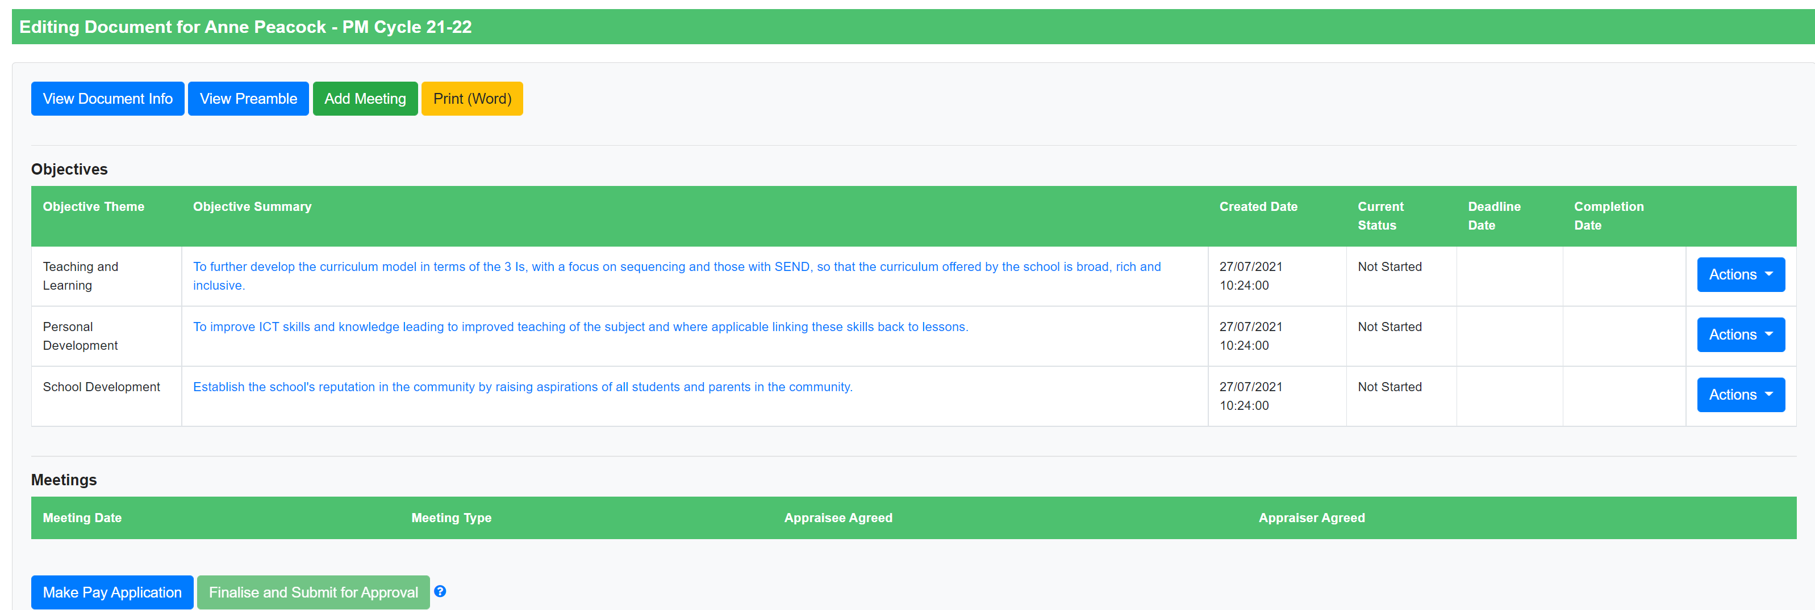

Completing Your Objectives
Each objective is stored in its own row in the ‘Objectives’ table. To view further detail for an objective or to edit it select the ‘Actions’ button followed by ‘View’ or ‘Edit’ on the right-hand side of the table (the ‘Edit’ option will only appear if your school has allowed you to edit your own document).
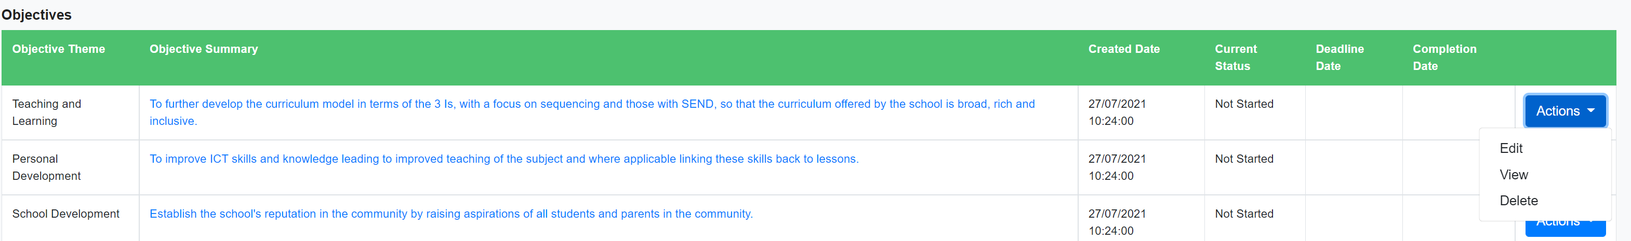
In the ‘Edit Objective’ pop up that appears, you will have the ability to upload evidence against each of your targets either by editing the objective detail section or uploading attachments at the bottom. Dependent on how your document has been set up by your school, you may also be able to link each objective to school development priorities and CPD events you have on the system.
Provided your school has allowed you to edit your own objectives, you should also be able to change the status of your objective by using the dropdown on the left hand side – don’t forget to update this as you make progress with your objective.
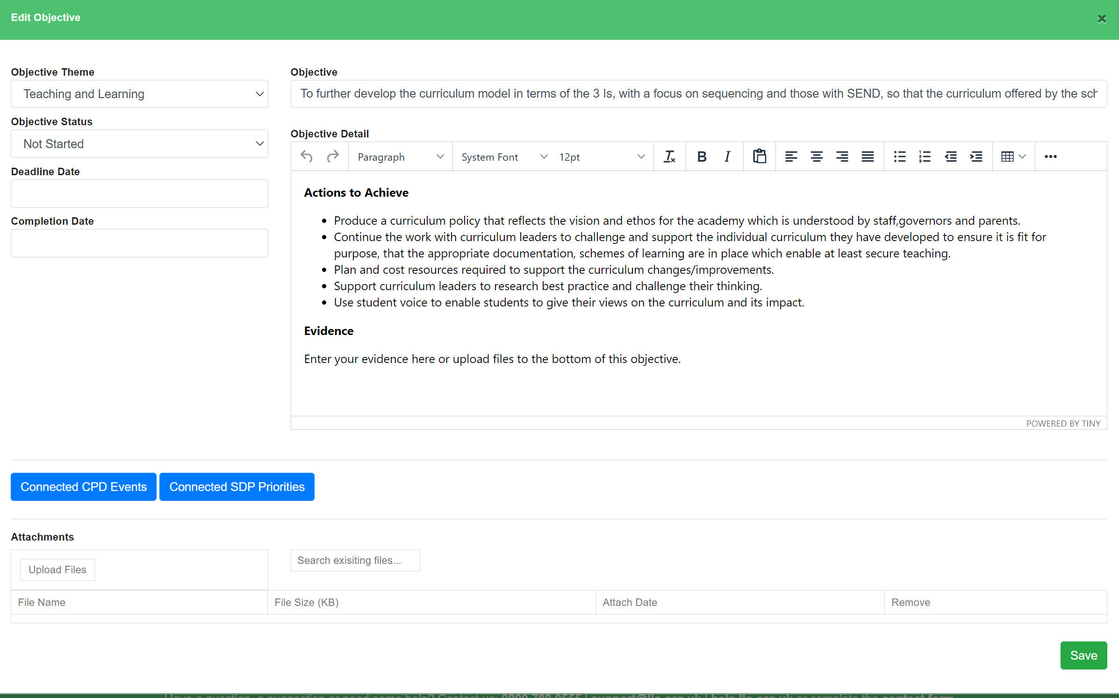

Logging Meeting Records
Throughout the year you can record the outcomes of any performance management meetings by using the ‘Add Meeting’ button at the top of your document (this will only be visible if you have permission to edit your own document).
Depending on your school’s set up you will see several different types of meeting, such as ‘Objective Setting’, ‘Interim Review’ or ‘Check In’. Pick whichever one feels appropriate and then select ‘Add Meeting’. You’ll then be presented with a pop up that allows you to add the details for that meeting. Add your comments in the ‘Appraisee Comments’ box and if there are ‘Appraisee Agreed’ and ‘Date’ fields, complete these too. When you’re finished, click ‘Save’ to close the popup.
If you’re unable to add a meeting, you’ll need to ask your appraiser to do this for you. Once it’s added to the table, you’ll then be able to access it to add your comments.

