Lessons Learned Professional Development Notes
Help Guide
Adding Professional Development Notes
Professional Development Notepads
To add a Professional Development Notepad, open the Teaching and Learning module and click ‘Create Notepad’. Select the date, note activity type (currently you will have two options – General Feedback and Learning Walk – contact support if you want to adjust this list), enter your contextual information and then click ‘Create’. You’ll be presented with the following:
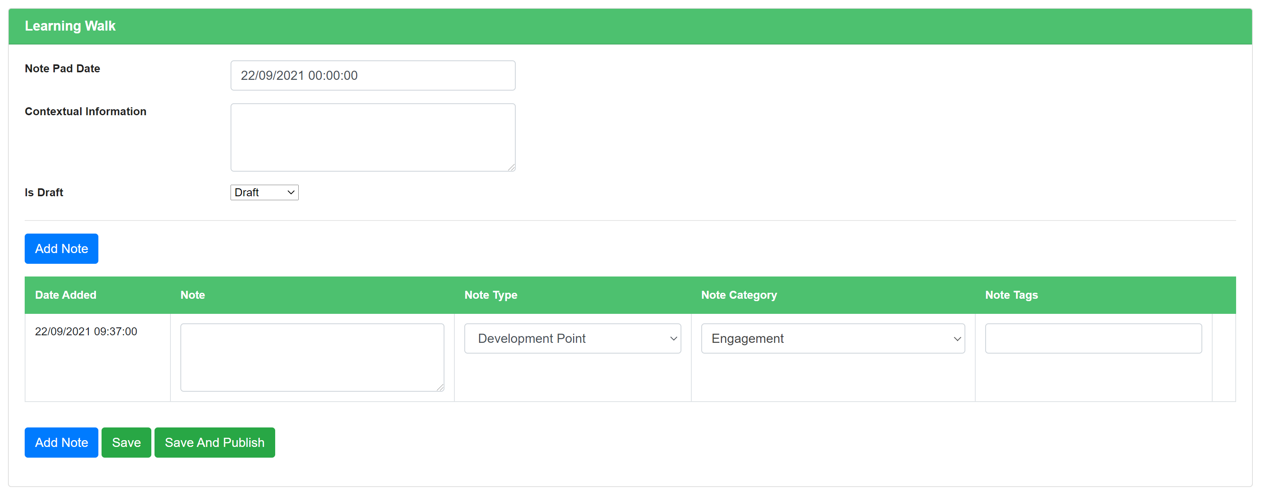
Start typing in the ‘Note’ box to add your first Professional Development Note. Then make sure you have the correct note type and note category selected before adding your tags for this note. NB. We still use both categories and subcategories for Professional Development Notes, however they all pull through to the same dropdown list, with subcategories sitting below main categories.
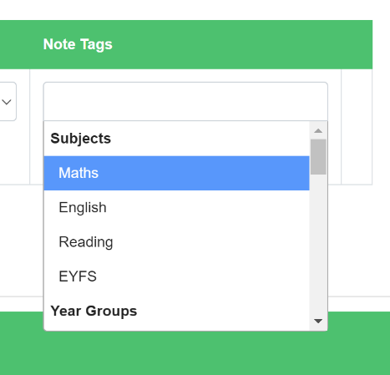
You can tag notes against subjects, year groups, individual staff and also staff roles (e.g. teaching staff).
Use the dropdown list that appears to find the entity you want to tag or start typing in the note tag field to filter the list down to exactly what you’re looking for.

You can then add a second note by clicking on either of the blue ‘Add Note’ buttons. When you’re ready to share all of the notes in your notepad, click ‘Save and Publish’. If you’re not ready to share yet, click ‘Save’ and return to the form later.
To return to any notepads you’ve created previously, go to the Teaching and Learning menu and select ‘View Notepads’. You can use the buttons at the top of this screen to show drafts only or only forms by you. Like with other forms on Teaching and Learning, only staff with the ‘Can View All T&L Forms’ permission will be able to access notepads by other staff (generally headteachers, SLT).
Adding Notes Against T&L Aspects
Unlike old Development Points and Strengths, Professional Development Notes are added against individual aspects, as opposed to the form overall. You will still be able to access old Development Points and Strengths at the bottom of T&L forms where they were previously added, but you’ll no longer be able to add new ones.
To add a Professional Development Note against an aspect, click the blue ‘Add/Edit Note’ button that appears in the aspect section.
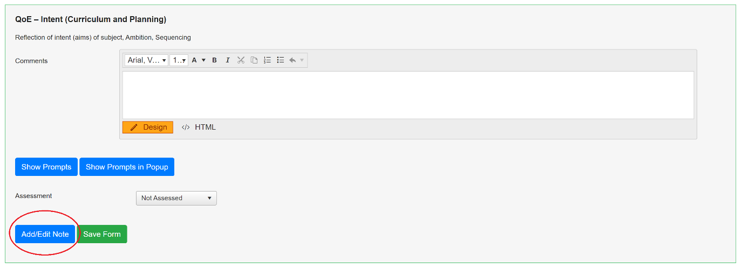
You’ll be presented with a pop up that contains a form for adding new notes and a table at the bottom where notes will be stored as you add them.
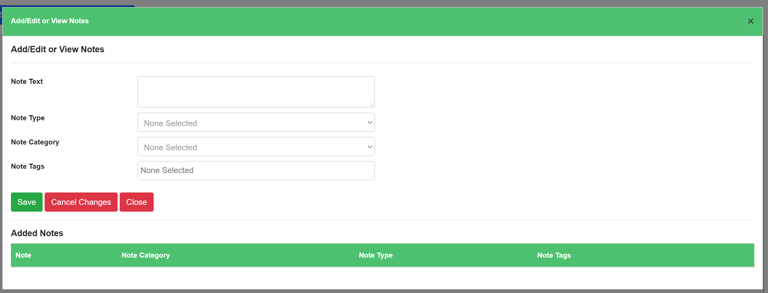
Add as many notes as you need to and then press ‘Close’.
Remember that even if you have created a form type on a specific person, you can still assign notes to any subject, year group, person or role from within the Professional Development Note pop up.
A summary of the notes you have added against all aspects in that form will appear towards the bottom of the page.
Adding Notes Against 360 Spokes
To add a Professional Development Note against a spoke, open up the 360 review you wish to edit and then click on the relevant spoke to bring up the spoke pop up.
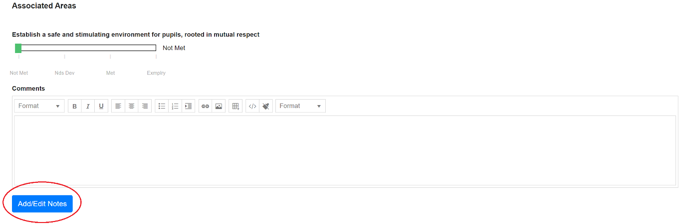
Every subspoke will have it’s own ‘Add/Edit Notes’ button, as will the overall/main spoke at the bottom of the popup. Click this button and you’ll be presented with another pop up that allows you to view notes already added and add new ones.
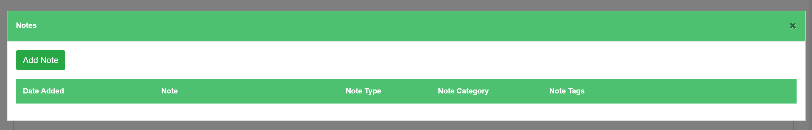
Click ‘Add Note’ when you want to add a new note to this spoke and you’ll be presented with the following:
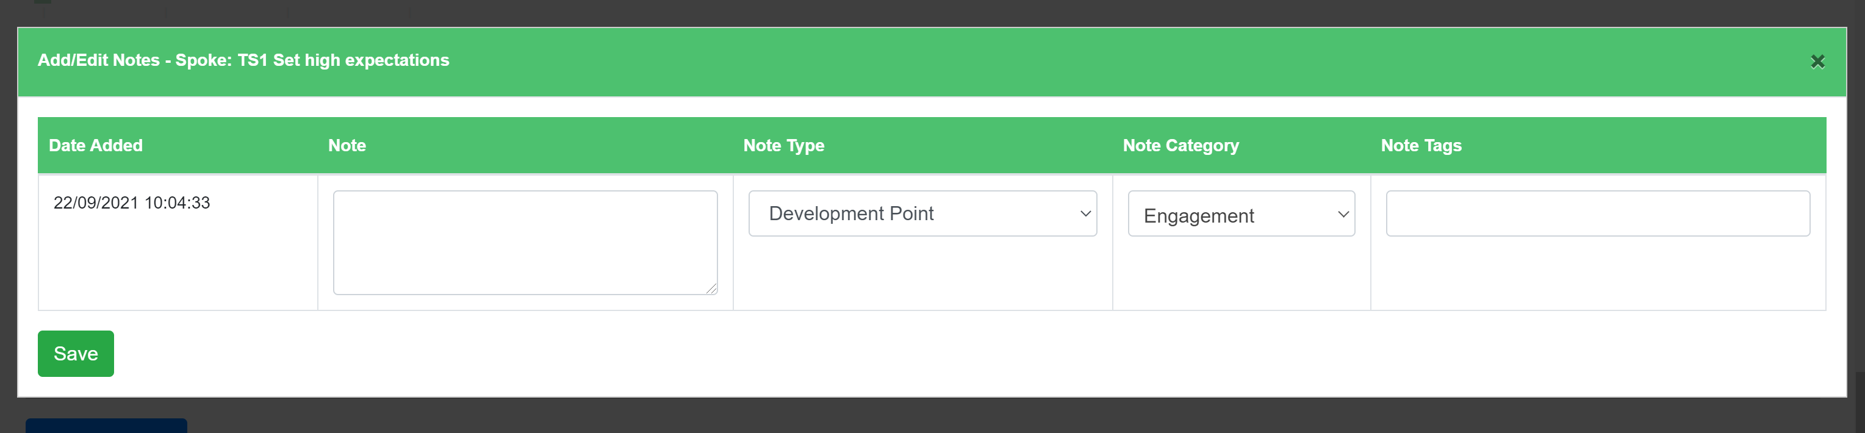
Click ‘Save’ and if you don’t need to add any additional notes, click the cross in the top right hand corner to close the notes pop up. To get back to notes for that spoke, just click the ‘Add/Edit Notes’ button again.

