Lessons Learned 360 Review Module

360 Review Guide – Wellbeing

To begin, go to www.llo.org.uk. Log in using your usual username and password (if you do not know these, please contact us at support@llo.org.uk).
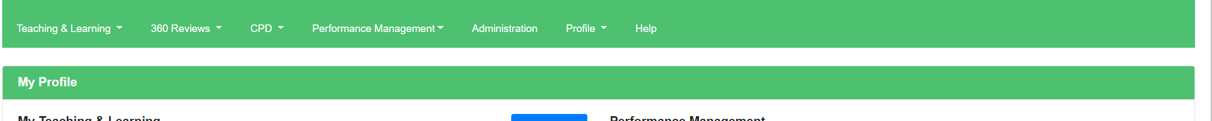
Once you have logged into the system your Lessons Learned profile screen should appear with the navigation bar at the top of the screen (if logged in on a small device such as a phone or tablet, you’ll see three lines ☰ for the menu instead).

Creating a 360 Review
To create a new 360 review, you will need to select ‘360 Review’ on the top toolbar, then ‘Wellbeing’ followed by ‘Create Review’.
You will then need to add a ‘Review Date’ and ‘Review Title’ - making sure the title is relevant, such as the term in which the review is being conducted. Your school may have pre-populated review titles which will appear within a drop down as you begin to type.
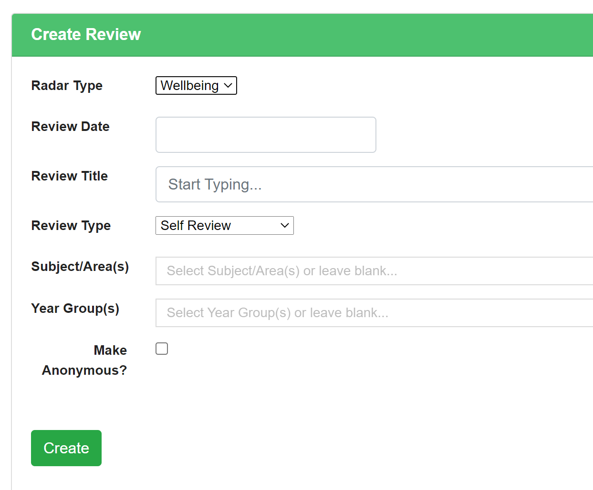
As this is a self-review, the review type will remain the same.
N.B – Depending on the review type you are completing; you may see the option to make the review ‘anonymous’ or to ‘keep private’. The anonymous option will replace your name with the word ‘Anonymous’ and the keep private option will hide the review from everyone else in the system, including SLT.
Finally select ‘Create’.

Completing a 360 Review
Once you have selected ‘Create’ it will take you directly into the wellbeing self-review as below.
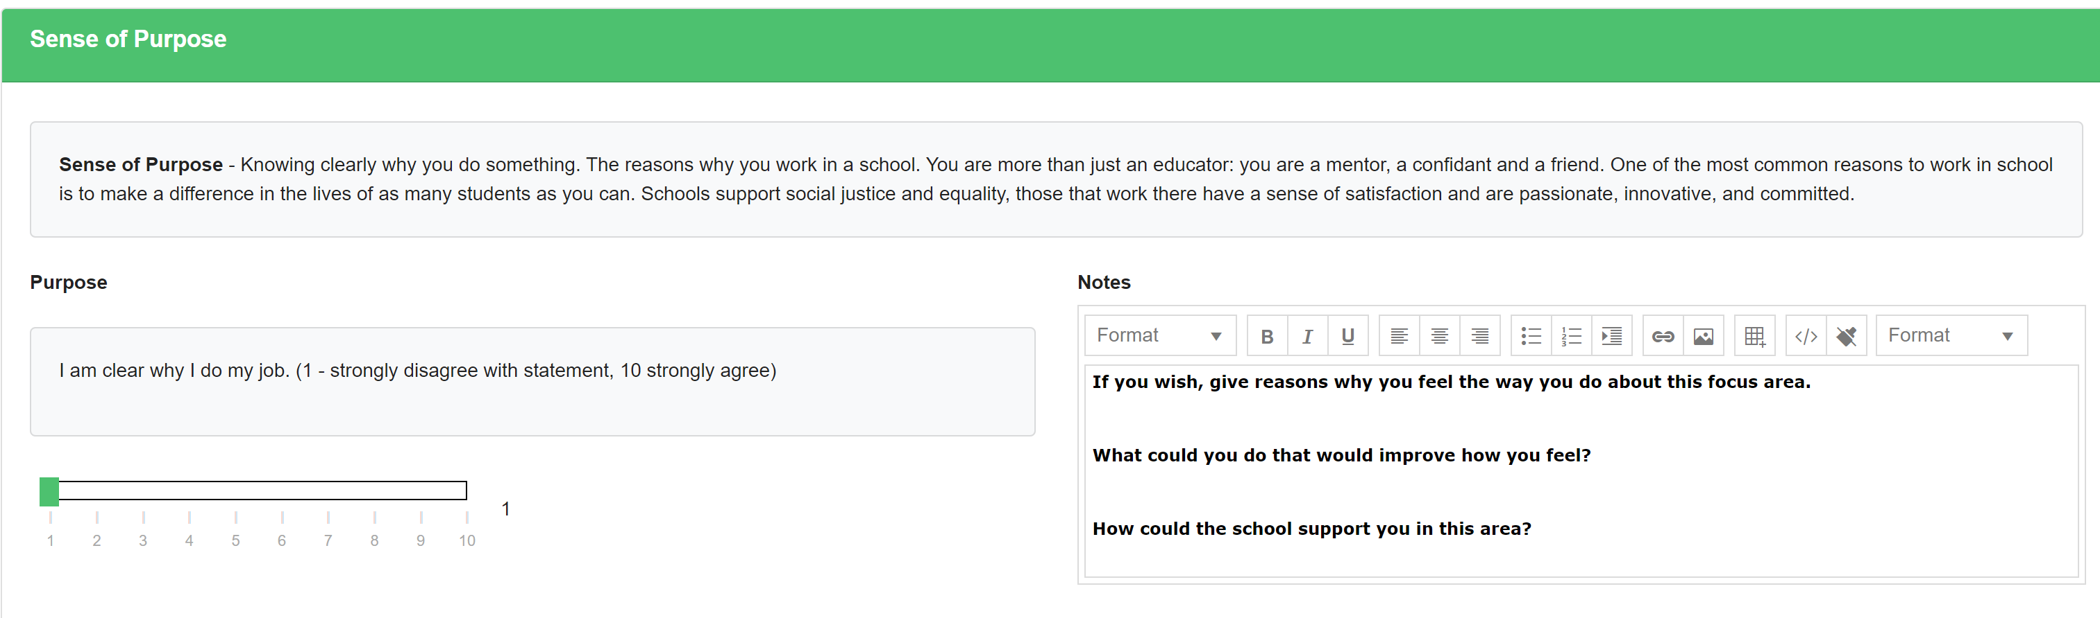

There are 8 sections in total and for each section there are four statements to answer against. The first section is ‘Sense of Purpose’ and the first statement for this section is ‘I am clear why I do my job.’ Against each statement there is a slider which can be moved on a scale of 1 -10. Alongside each slider there is a comments box where you can provide further information on your answer.

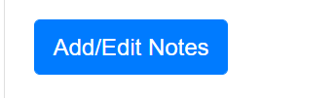
Alongside each spoke you will see you will also see the option to ‘Add/Edit Notes’. Using this feature will allow you to add a professional development note as seen within the image below.
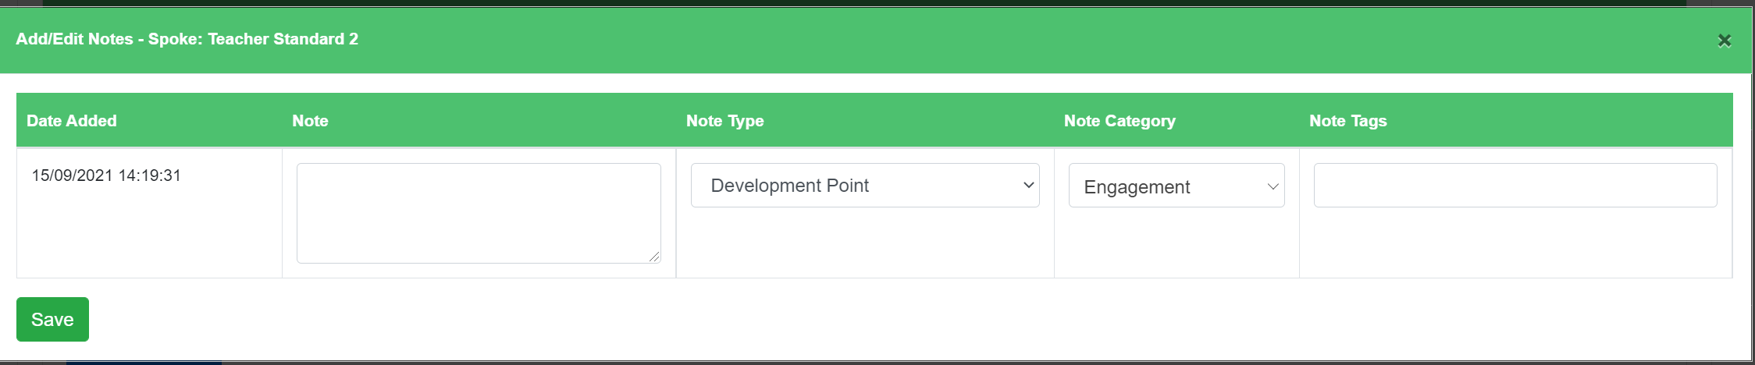
Once each four statements have been answered, there will be an overall judgement that will calculate automatically, based on an average that has been selected above. If you feel this overall judgement does not show a true reflection of your wellbeing in this area, you will have the option to override the automatic calculation but bear in mind it will be flagged that you have chosen to do so. There is also a comments box to complete if required. At the bottom of every section there will be an option to add any attachments as evidence.
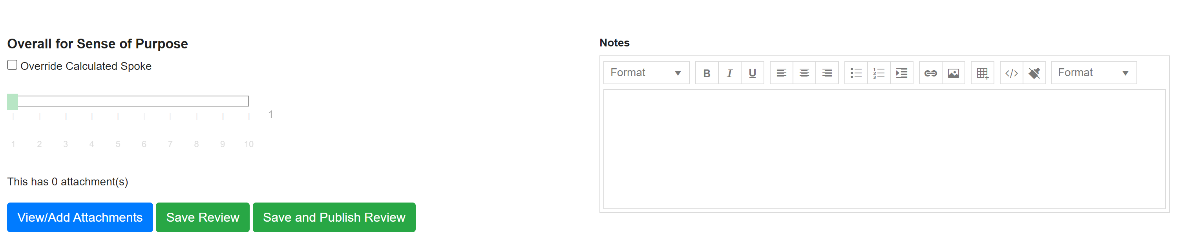
There is also an option to ‘Save Review’ or ‘Save and Publish Review’ under each section. This can be used if you want to exit the Review and complete at a later stage. Alternatively, you can move down the document to the next section.
At the end of the document there is an ‘Overall’ section. In here you’ll find a comments section where you can address any concerns or points that need to be addressed and you’ll also see the spider diagram that your review has created with one spoke for each section answered.
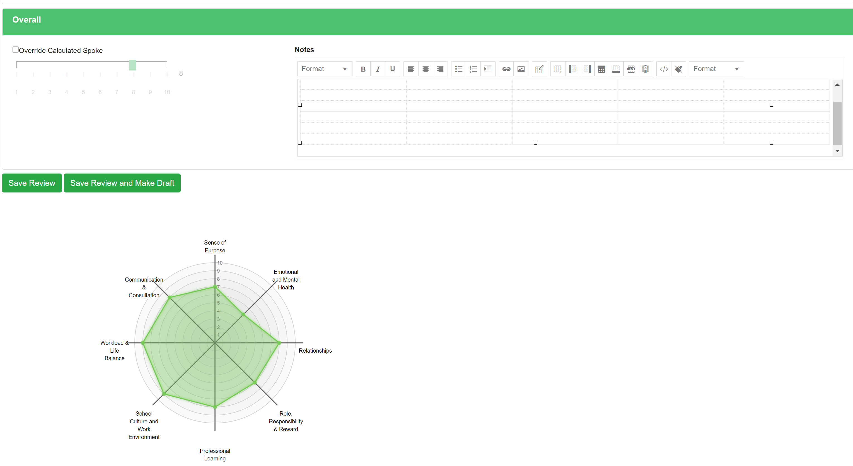

Viewing 360 Reviews
Click ‘360 Review’ followed by ‘Wellbeing’. Select ‘View Reviews’ and the screen will refresh to show you all the of the reviews you have been given access too. If you are head of a department, you will have access to the reviews that have been created accordingly.
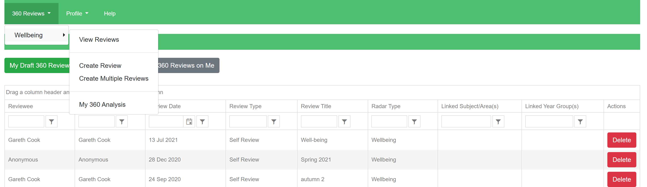
To view any of the listed reviews click on the review and the screen will refresh and show the information required.

Editing a 360 Review
Click ‘360 Review’ followed by ‘Wellbeing’. Select ‘View Reviews’ and the screen will refresh to show you all the of the reviews you have access to.

Publishing a 360 Review
First, find and open the 360 review you would like to publish. At the bottom of the review document, you will see a green button to ‘Save and Publish Review’. This appears on every ‘Survey’ radar in each spoke.
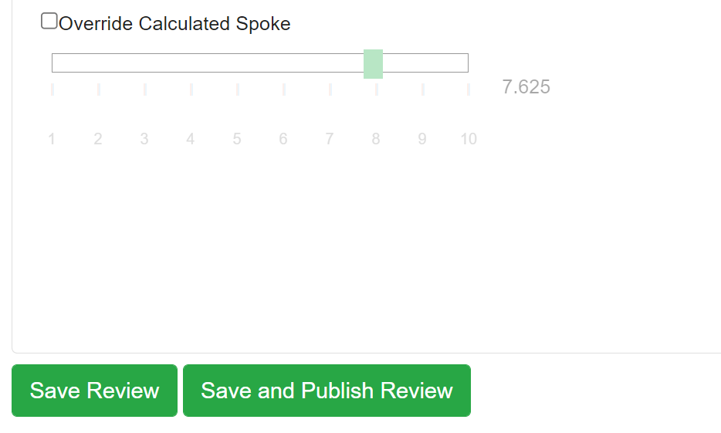
Completed and published reviews can then be compared by layering the reviews one on top of the other, giving you instant, high-impact visual reports of progress at all levels.

Analysing 360 Reviews - Individual
Click ‘360 Review’ followed by ‘Wellbeing’ and select ‘My 360 Analysis.’
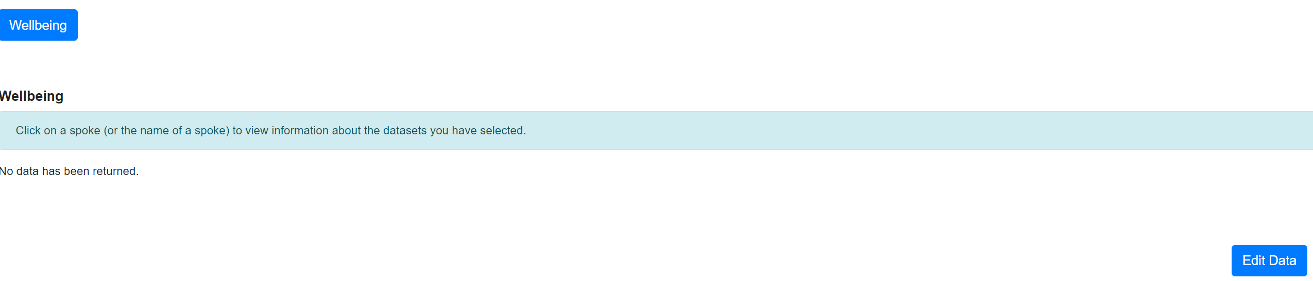
Select ‘Edit Data’ and then ‘Select Reviews.’ Make sure the filters are set to show reviews for the correct time period (by default you’ll see reviews for the last calendar year).
The system will refresh and then list all the published reviews that are available to select. You can select as many as you would like by clicking on the reviews listed and then selecting ‘Update Selected Reviews.’ This will move the reviews into the table above.
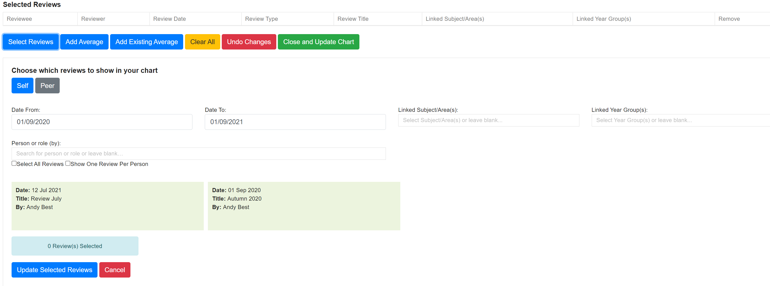
Click the green ‘Close and Update Chart’ button and the completed and published reviews will then be shown in the radar chart visual, layering the reviews one on top of the other.
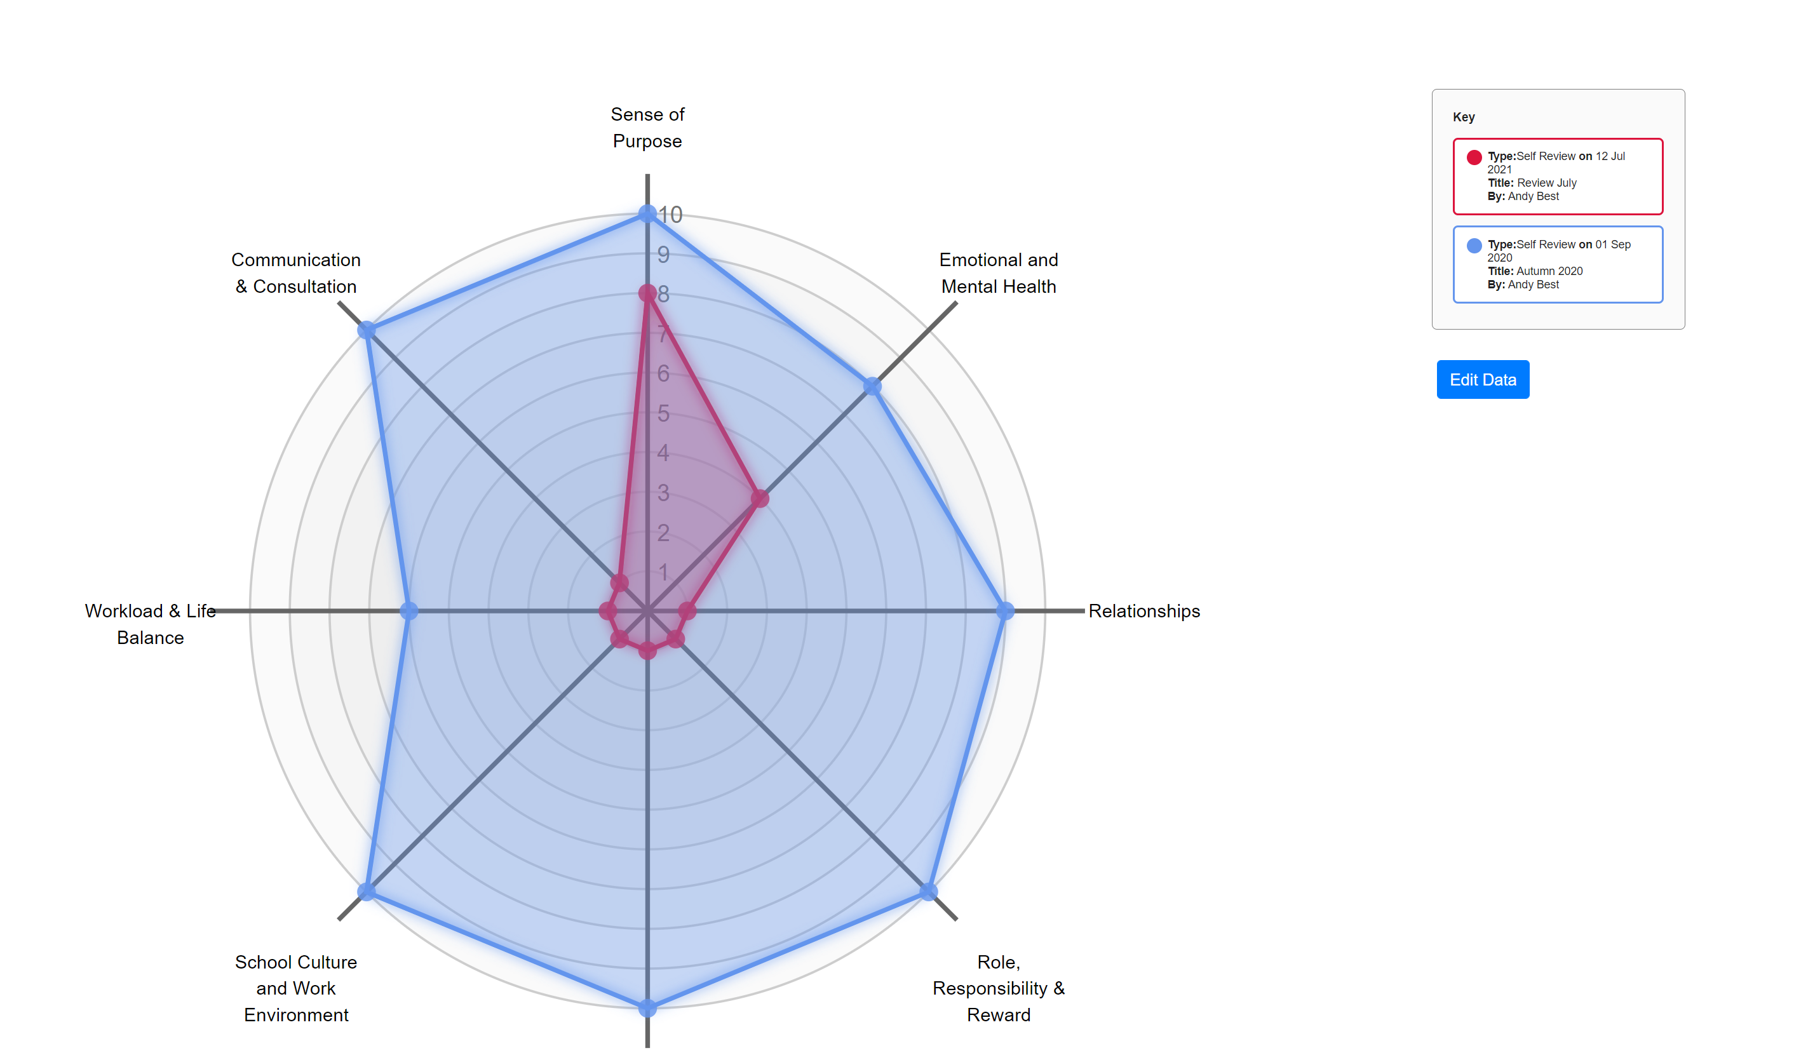

Analysing 360 Reviews – School (SLT Only)
To compare the results of your Wellbeing reviews at school level, use the ‘School 360 Comparison’ or ‘School 360 Reporting’ pages. The first option will allow you to compare wellbeing reviews by role type – i.e. how teachers on average compare to TAs, to SLT, etc. You can then add additional averages into the chart by using the ‘Add/Edit Averages’ button at the top of the screen.
The ‘School 360 Reporting’ page will show a box and whisker plot of all of your reviews from the last year (by default, change the filters if you wish to view data for another time period). Longer bars mean there is a wider spread of data. Shorter bars mean that more people are responding the same way. Bars higher up on the plot generally represent more positive responses, whereas bars lower down generally represent more negative responses. You can see the same data in a tabular format further down the page and you can also access a summary of comments for each section here by clicking on the ‘Comments’ tab (seen below).
