Lessons Learned Professional Development Notes
Help Guide
Addressing Professional Development Notes
In order to close the school improvement loop, it’s vital to ensure that any concerns reported are addressed properly and then marked as dealt with. Whilst it was possible to do this with the old Development Points, many schools were not using that feature and so we wanted to make this process easier and clearer with Professional Development Notes.
Notes Reporting
The Notes Reporting screen allows you to see a summary of all Professional Development Notes from across the system. Like many other screens in Lessons Learned, it’s access based so individuals with no department responsibilities will only get access to notes added by them or notes for them (or their role) on this screen. SLT will get access to all notes and department leads will get access to notes related to their year group or subject.
At the top of the Notes Reporting screen there are a number of filters which allow you to specify things like Note Category, Note Type and so on.
Directly below the filters are two charts which visualise your data based on category (how many notes assigned to each category) and note type (how many notes assigned to each note type).
Professional Development Notes are then summarised in the table below, along with all the subjects, year groups, people and staff roles that they were tagged with. From this page you can:
- add action plans against notes related to their tags;
- mark notes as complete and confirmed complete for each tag.
To add an action plan for a Professional Development Note related to a particular tag, click on that tag in the table (shown as a green ‘Reading’ tag in the example above) and you’ll be presented with a pop up with the following areas:
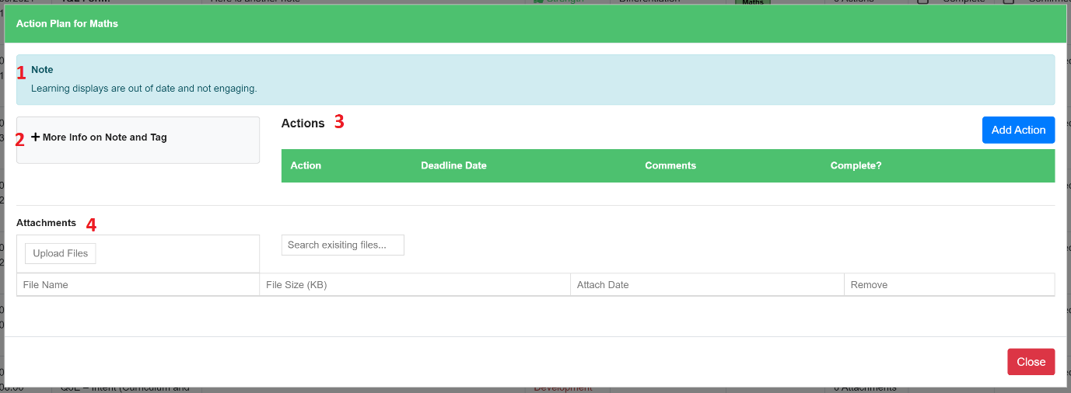
- A summary of the note that this subject/year group/person/role was tagged in
- An expandable section containing more information, such as note type, date added, etc
- An action table for logging actions related to this particular tag
- An attachments table for adding evidence of what was mentioned in the note or the actions put against that note
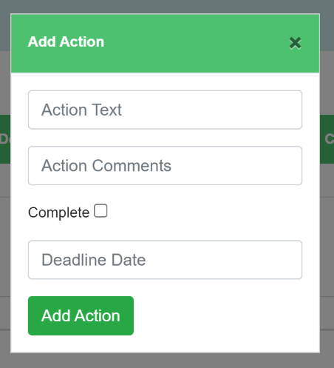
Clicking on ‘Add Action’ will allow you to record the action, any comments related to it and a deadline date. You can also come back and mark the action as complete later on, either from within the pop up or within the actions table itself.
Actions plans can also be accessed from within 360 Reviews by clicking on tags. They cannot currently be accessed from within T&L forms, but this feature is in the pipeline.

When all actions have been met and the Professional Development Note is no longer an area of concern, it’s important to then mark it as complete. Once it’s been marked as complete, you may also like somebody else to confirm it as complete. To mark a Professional Development Note as complete and/or confirmed complete for a particular tag, just click the checkbox in the table and it will update to show a purple tick:

If you need to see who marked a Professional Development Note as complete and/or confirmed complete for a particular tag, just click on the tag and expand the ‘More Info on Note and Tag’ section.

