Lessons Learned - Teaching & Learning Module

Help Guide

To begin, go to www.llo.org.uk. Log in using your usual username and password (if you do not know these, please talk to your school administrator).
Once you have logged in you will see your Lessons Learned profile page again and your navigation bar across the top of the screen (if logged in on a small device such as a phone or tablet, you’ll see three lines ☰ for the menu instead).
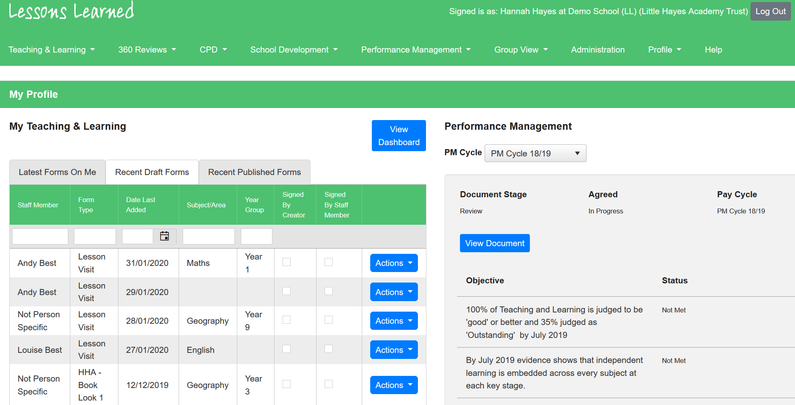
Creating a Teaching and Learning Form
- Select ‘Teaching and Learning’ from the toolbar, followed by ‘Create Form’.
- You will then be prompted to fill out the form details.
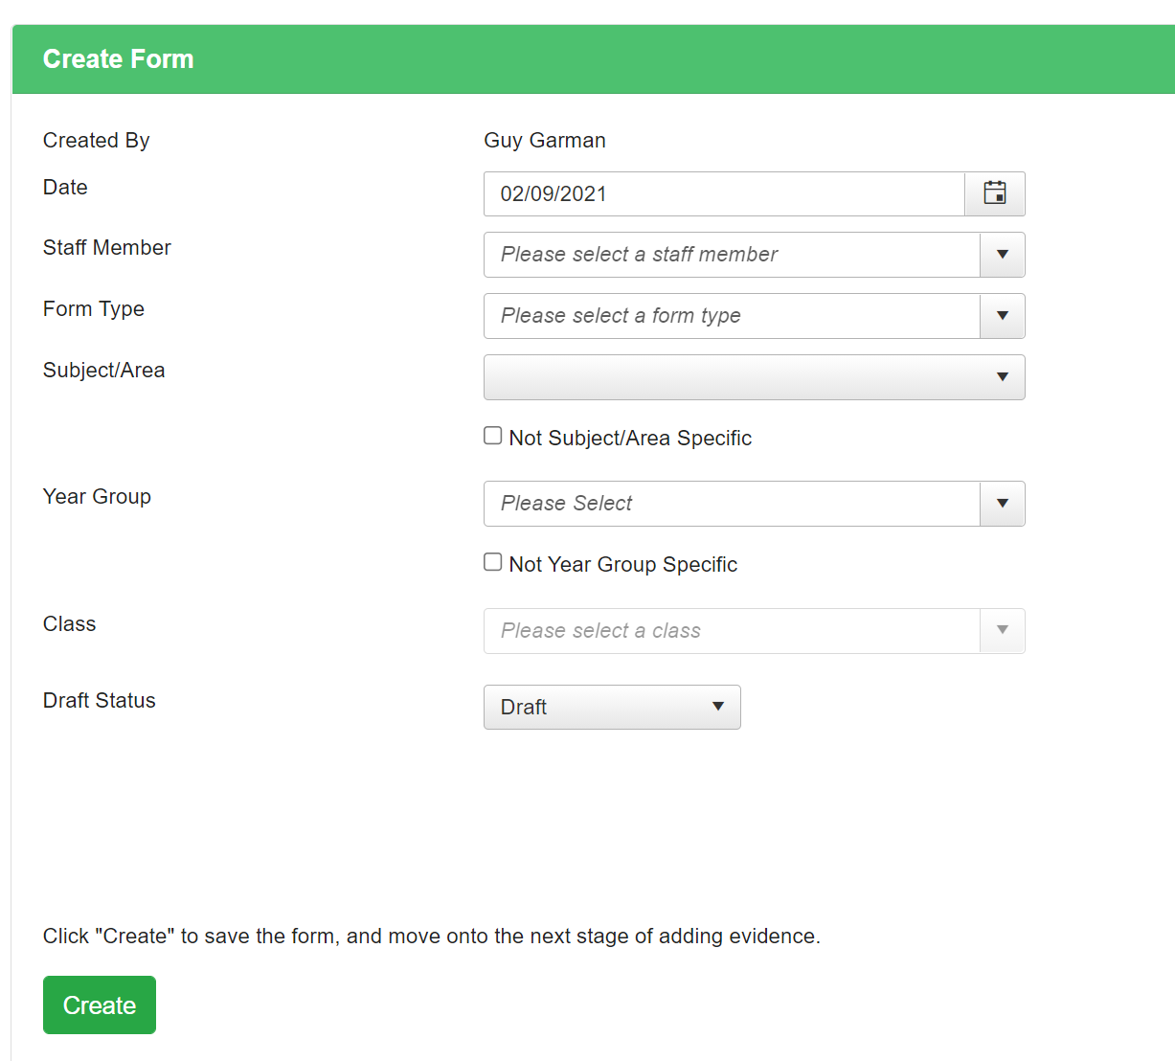
You’ll notice the system will automatically logs you as the creator of the form.

- Select a staff member form the drop-down list (there is an option for ‘Not Person Specific’ if necessary).
- Select the form type you would like to create from the ‘Form Type’ drop down.
- Select a subject/year group if applicable, and then select the appropriate class.

Please note if you do not select a class the system will not log this form against a year group.
You’ll notice a ‘draft status’ drop down. We recommend keeping all forms in draft until you have completed and are happy with each form. There will be several ways to publish a form one you have completed it.
- Click ‘Create form’. The system will refresh and the T&L form selected will be shown – in this case a ‘Work Scrutiny’ form.
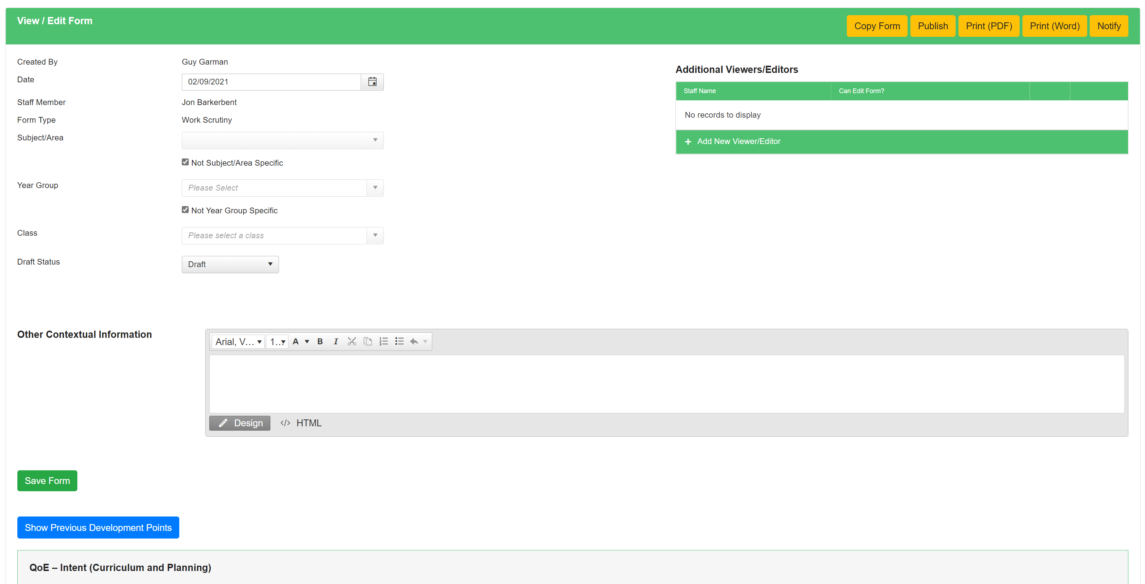

Adding Additional Viewers/Editors
The top right section will allow you to add another member of staff to view this form with you. You will also be able to turn on an option for the induvial to be able to edit the form. Simply click on ‘Add New Viewer/Editor’ and add their details.

Completing a Form
Depending on your school’s set-up of the form selected, you may be required to do any of the following for each of the aspects on the form – such as QoE – Intent (below).
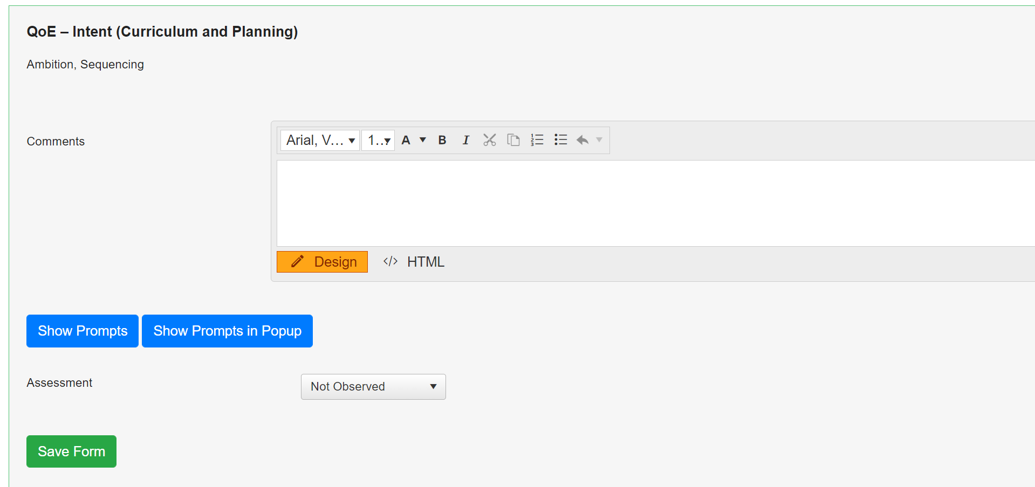
Adding Comments – Each aspect may have a text box for you to capture notes against each aspect.
Making Assessments – An aspect may have a drop-down box for you to assess each aspect.
Prompts/Descriptors – Each aspect may have a set of prompts/descriptors for you to click. To view these, click ‘View Prompts’ or ‘View Prompts in Popup’. Each statement can then be clicked once to turn green for ‘Met’ or can be double clicked twice to turn it red for ‘Not Met’. If you would like to remove a colour from a statement, simply click the prompt until the colour is removed.
Adding Professional Development notes – Each aspect will have the option to add/edit a note. Depending on your school set-up you will be able to add different styles of notes such as development points and strengths.
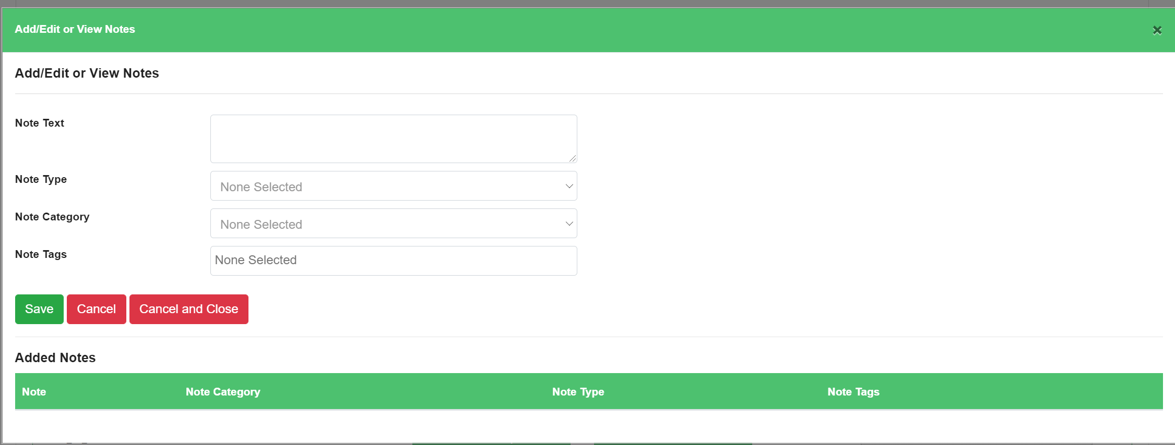
Remember to click ‘Save Form’ once changes have been made.

Adding Attachments and Links
At the bottom of the form there is an area where supporting evidence can be uploaded by either the Form Creator or Staff Member.

Editing The Teaching & Learning Form
Select ‘Teaching and Learning’ from the toolbar, followed by ‘View Forms’. A list of your Draft Forms will be shown.
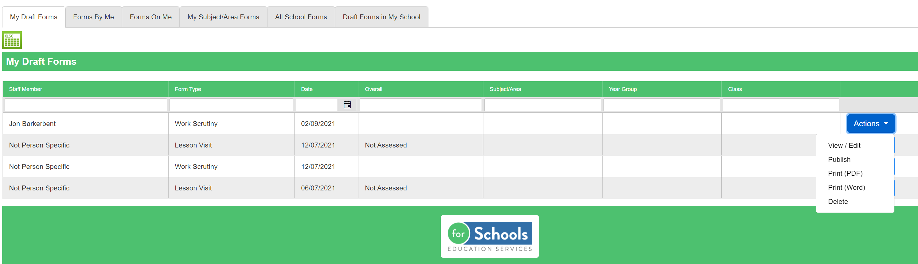
Find the form you wish to edit and select ‘View/Edit’ under the ‘Actions’ button. The form will be displayed, and you can make any necessary amendments before saving the document again. You can also choose to ‘Publish’, ‘’Print’ or to ‘Delete’ the form under the ‘Actions’ button.

