Lessons Learned Performance Management System

Appraiser/Coach Guide

To begin, go to www.llo.org.uk. Log in using your usual username and password (if you do not know these, please contact us at support@llo.org.uk).
Once you have logged in you will see your Lessons Learned profile screen and your navigation bar across the top (if logged in on a small device such as a phone or tablet, you’ll see three lines ☰ for the menu instead).
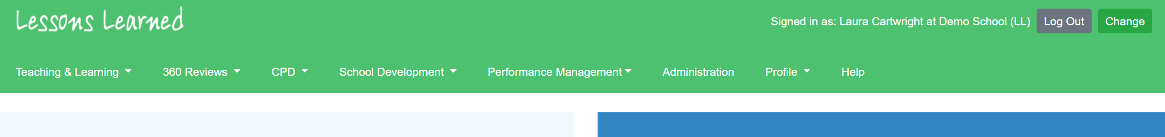
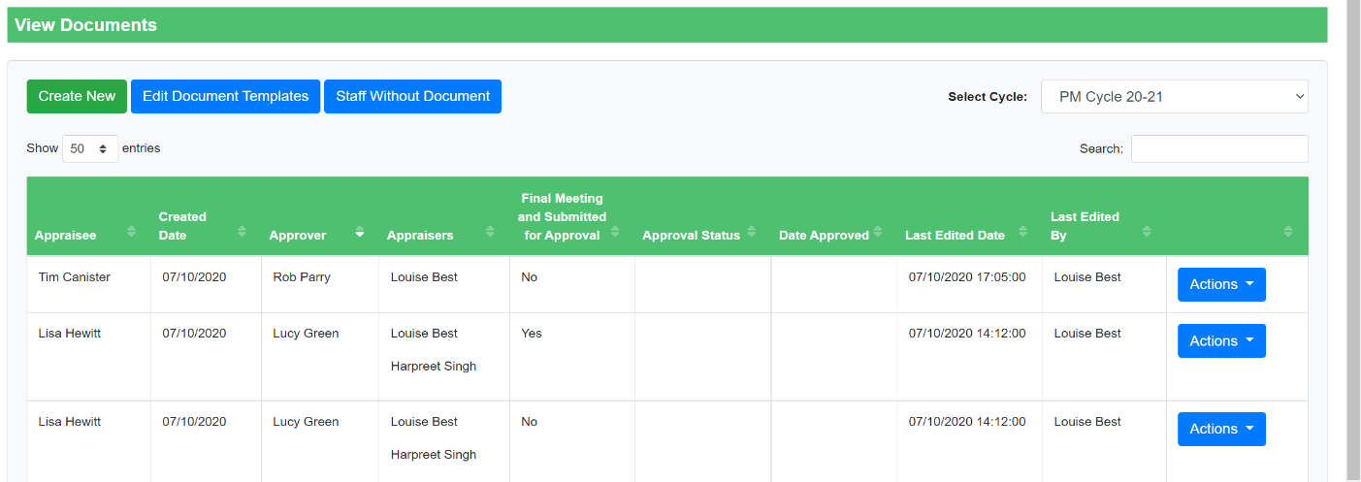
Click ‘Performance Management’ followed by ‘Documents’ and the screen will refresh to show you all the appraisal documents in which you are involved.

Creating a New Document
Begin by clicking the ‘Create New’ button. The page will refresh, and you will then be able to select the key details of the appraisal form.
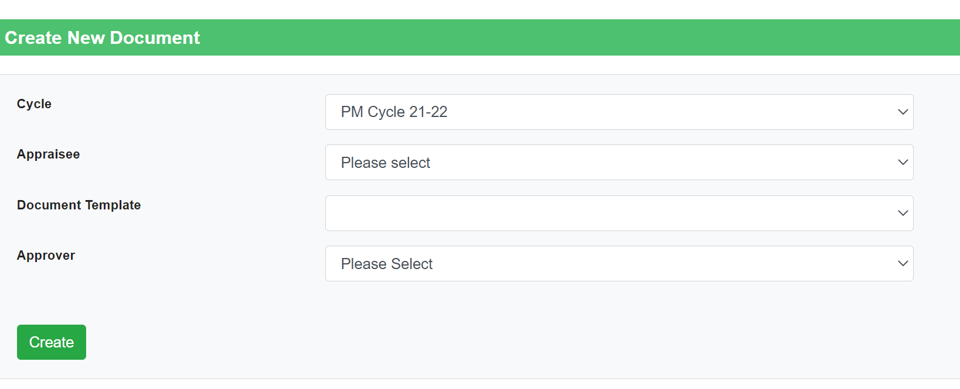

- Select the relevant cycle.
- Select your appraisee. If you are unable to select a staff member to appraise, please speak to your school administrator or contact us at support@llo.org.uk and we will be able to set you as an appraiser. Please note we will need confirmation from the headteacher in order for us to make any changes to the appraisal structure.
- Select the appropriate document template on which to base the document on.
- Select the overall approver (usually the headteacher).
Select ‘Create’ – the system will refresh and show the document created for that member of staff.
The layout may vary slightly depending on how the document templates have been set up. Below is an example where the document template includes 3 objectives.
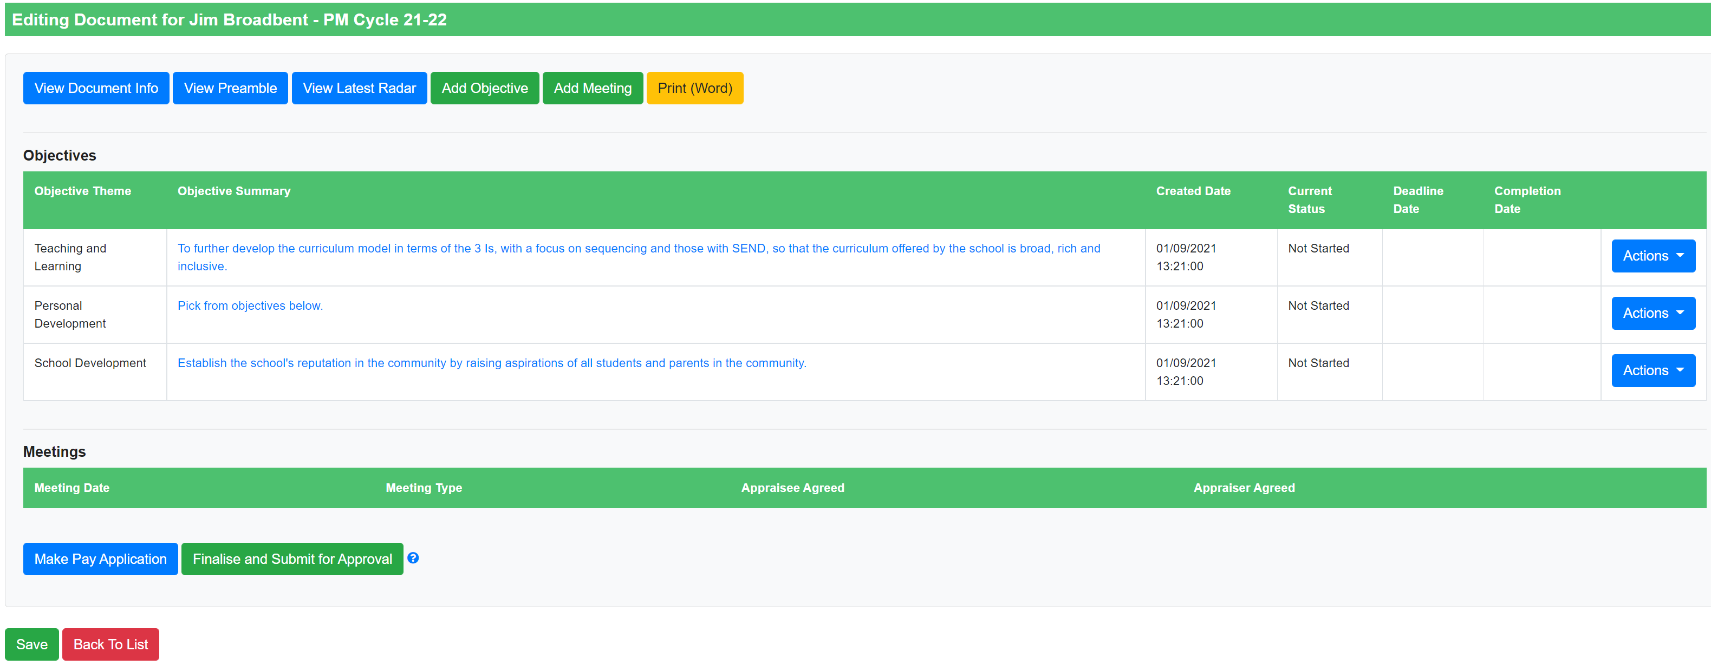
Each objective in the above example has the following:
Objective Theme – essentially a ‘Category’ for that objective (used by SLT for reporting purposes).
Objective Status –reflects the progress made against each objective and is updated throughout the year.
Deadline and Completion Date – optional date fields.
Objective Summary – a brief description of the objective.
Under the ‘Actions’ button alongside each objective you will be able to ‘View’, ‘Edit’ or ‘Delete’ each objective.

Editing an Objective
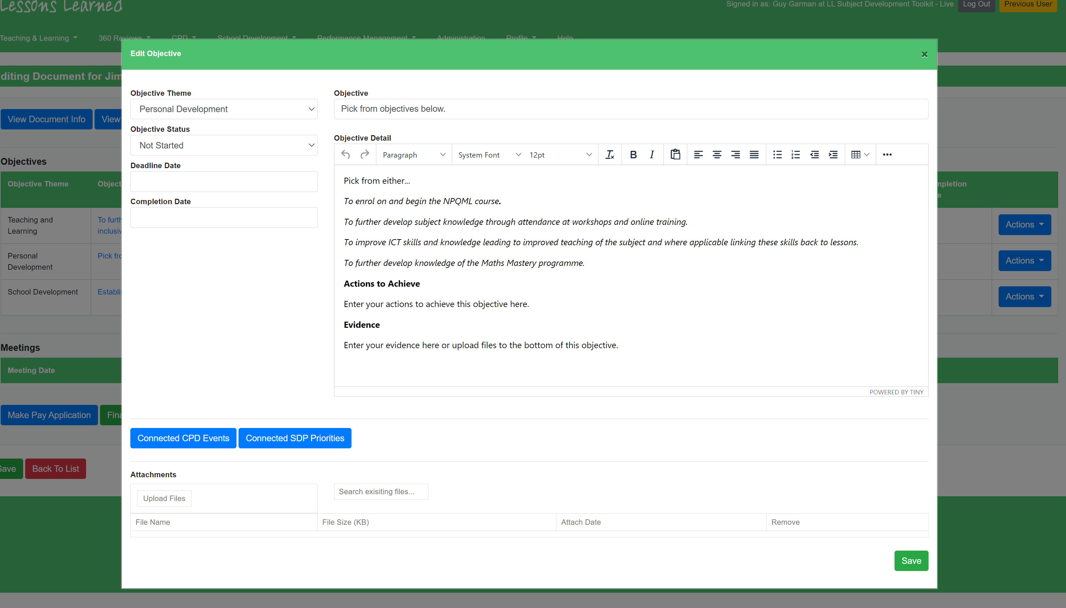
Click ‘Actions’ > ‘Edit’ if you’d like to make changes to an objective. The ‘Edit Objective’ popup that appears allows you to change any of the features mentioned above, as well as the ‘Objective Detail’. Depending on how your school has set up their document templates, the ‘Objective Detail’ might contain sections for ‘Actions to Achieve’, ‘Success Criteria’ or anything else. If you are unsure of what to include in this box or the headings are not clear, please talk to your SLT as this will be specific to your school.
After any changes are made select ‘Save.’

Adding Meeting Logs
You can add meeting logs with the ‘Add Meeting’ button at the top of the page.
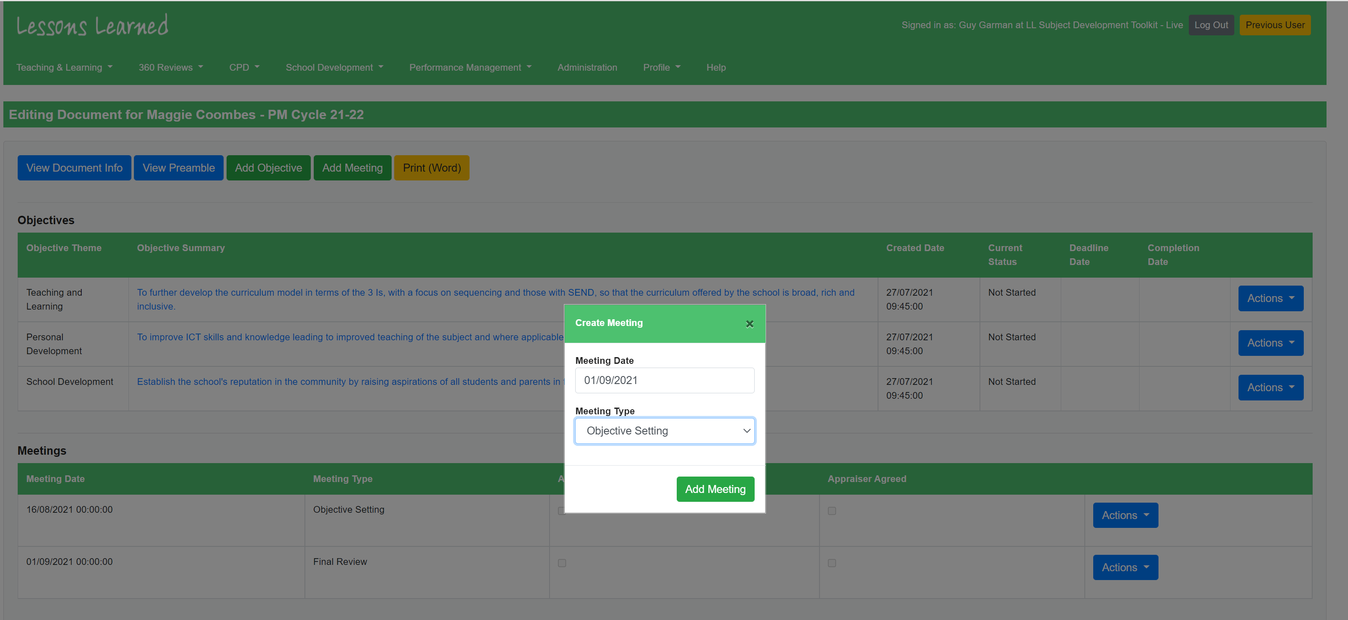
Depending on your school’s set up you will see several different types of meeting, such as ‘Objective Setting’, ‘Interim Review’ or ‘Check In’. Pick the relevant one and click ‘Add Meeting’ and you’ll then be presented with a pop up that allows you to add the details for that meeting. Add your comments in the ‘Appraiser Comments’ box and if there are ‘Appraiser Agreed’ and ‘Date’ fields, complete these too. As the appraiser, you can also complete the appraisee sections on their behalf if you are in the meeting together. If not, click ‘Save’ to close the popup and the appraisee will be able to add their own comments when they next log in.
Please note that if your school is not set up to allow appraisees to edit their own document, your appraisee will not be able to add meetings themselves. You will need to add the meeting before they are able to go in and leave their comments.
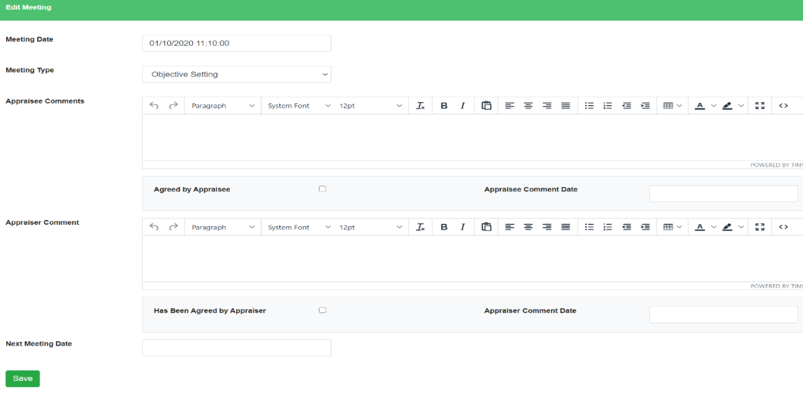

Submitting a Document for Approval
At the end of the PM Cycle you will need to finalise the performance management document and submit it for approval. This should only be done once all meetings have been held and objective statuses have been updated to reflect any progress made.
Depending on your school’s set up, you may see a blue button that says ‘Make a Pay Application’. If so, click this to reveal boxes for collecting extra information that your school has requested as part of your pay application process. Both appraisee and appraiser will need to confirm this is complete and date it.
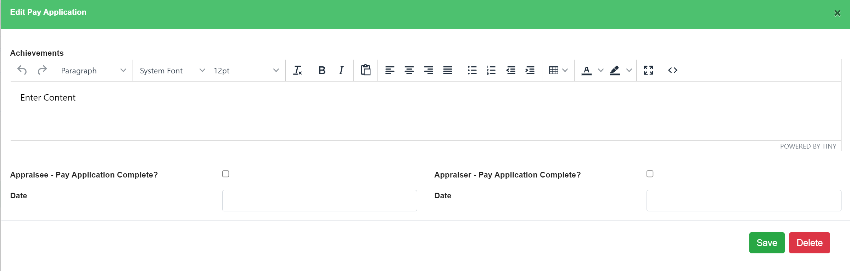
Once any pay applications information has been added, you can submit the document for approval using the green 'Finalise and Submit for Approval’ button. Within this section you can recommend your appraisee for a pay change using the yes/no drop down and enter in any final comments before saving. Note that if your school does not use the system for dealing with pay, you will not see the pay change dropdown.
